The New Mexico Department of Veterans’ Services (DVS) presented its annual Memorial Day Ceremony on Monday, May 27, at the Vietnam Veterans Memorial in Angel Fire.

Speaking to the crowd gathered in the Memorial’s amphitheater, DVS Cabinet Secretary/Brigadier General Jamison Herrera focused his opening remarks on the importance of not losing sight of the true meaning of Memorial Day.

“Today I ask all Americans…and all New Mexicans…to remember that Memorial Day is more than just the unofficial start of summer. It is more than just a three-day weekend,” said Secretary Herrera *(photos below)*. “Please remember that Memorial Day is a day to honor…to cherish… to remember…and to thank the men and women who lost their lives while in military service. To think otherwise would disrespect the legacy of those who paid the ultimate sacrifice—for our freedom, and for our country.”

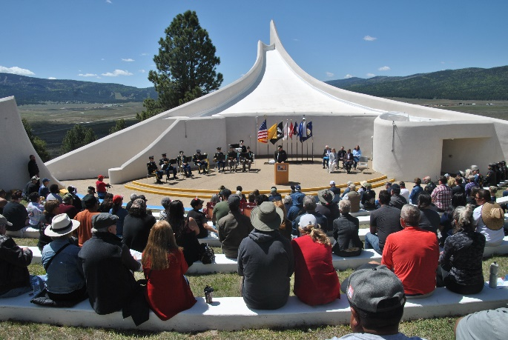

Following Secretary Herrera's remarks, the keynote address was delivered by renowned photorealism artist Denham Clement *(photo below)*. The former U.S. Marine Corps captain spoke about his combat experience in South Vietnam during the Vietnam War. The Albuquerque resident said he eventually turned to art a few years after returning home—not knowing what to do next, and not able to forget what he experienced--and lost---in combat. Much of his art is influenced by his war experience.

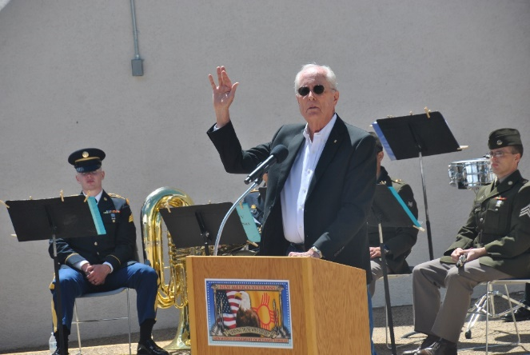

“The heroes all stepped across that line. They found purpose in dedicating themselves to a greater cause, without concern for their personal safety or comfort,” said Elliot, who said he was able to find peace after moving to northern New Mexico after the war to finally pursue art as a career. *(photo below)* “Even though it happened a long time ago, somewhere among the causes and the chaos of the Vietnam war might still lie our identity as Americans. We need to reflect on these images, and listen to these echoes of the past, in order to heed them, and listen to them…for fear not only that they might be forgotten, but that they might be erased.”

**Additional photos:**

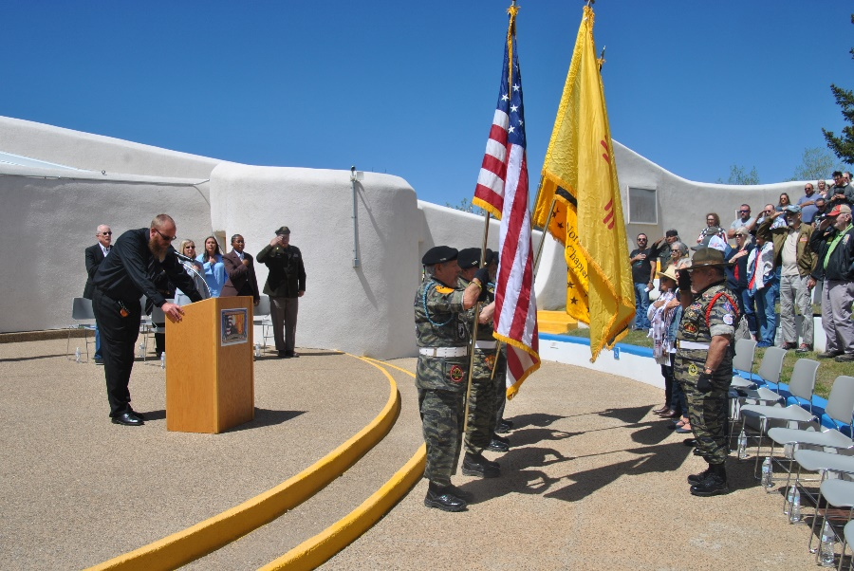

Vietnam Veterans Memorial Administrator Ernie Sutliffe (at podium) leads the Pledge of Allegiance moments after The Colors were presented by the Vietnam Veterans of American/Northern NM Chapter 996 Color Guard.

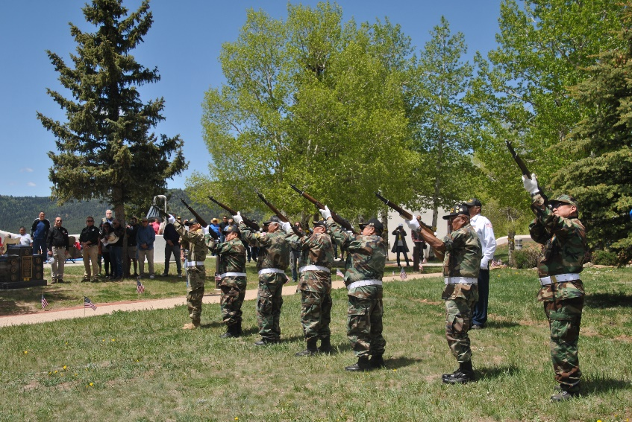

*(above photo)* The Vietnam Veterans of American/Northern NM Chapter 996 Color Guard performed a 21-shot rifle volley after the keynote address.

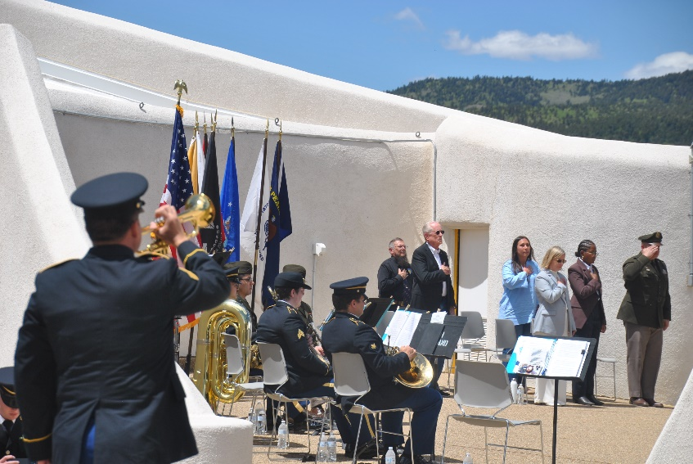

*(above photo)* A bugler from the 44th United States Army Band rendered a "live" rendition of Taps following the rifle volley.

*(below photo)* DVS Cabinet Secretary Herrera presents a DVS coin to Keynote Speaker Denham Clements.

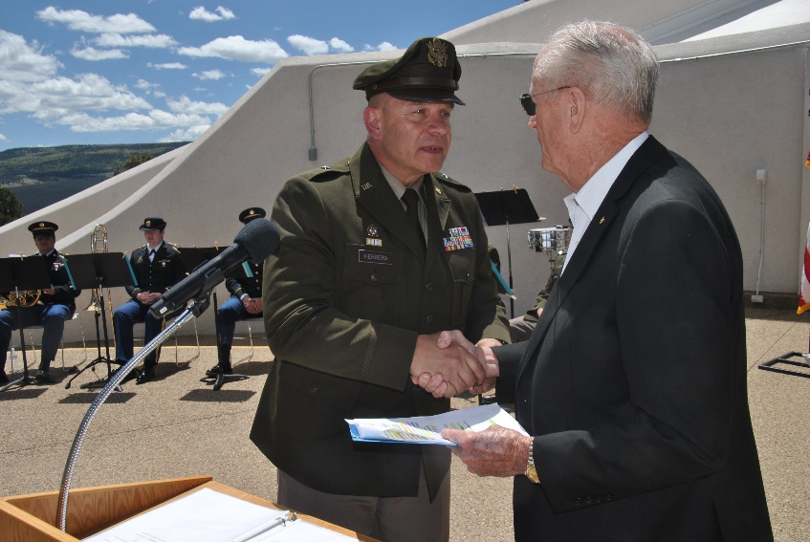

*(below photo)* DVS Cabinet Secretary Herrera presents a DVS coin to ceremony Master of Ceremonies Beth Tafoya.



