DVS presented the 2024 New Mexico Women Veterans Conference on June 8 in Albuquerque at the Sheraton Uptown Hotel.

150 women veterans and vendors registered for the conference, which focused on educating women about U.S. Department of Veterans Affairs (VA), state, and local community benefits available for veterans.

According to the VA, women make up the fastest-growing segment of our nation’s veteran population. VA data shows there are two million women veterans in America--about 11% of our nation’s 18.2 million veterans. Here in New Mexico, 12% (16,900) of our state’s 141,700 veterans are women.

DVS Cabinet Secretary Jamison Herrera opened the conference by noting that women have been working in some capacity in the military since our nation’s Revolutionary War. He said it’s important that women who’ve served apply for the benefits they’ve rightfully earned for serving our country *(above photo)*.

“We are all brothers and sisters in arms—regardless of demographic,” said Secretary Herrera, who is also a current New Mexico Army National Guard brigadier general and the state’s deputy adjutant general. “It is my job, and the job of everyone at DVS, to make sure not only that you get the benefits you’ve earned, but also the respect you should get as veterans.”

Secretary Herrera also urged attendees to help spread the word about two veterans’ property tax exemption measures that will appear on this November’s general election ballot. One will ask voters to increase the veterans’ property tax exemption from $4,000 off the taxable value of their home…to $10,000. The other ballot measure will ask voters to approve a new service-connected disabled veterans’ waiver to be based on a veterans’ VA service-connected disability rating. Currently only 100% service-connected rated veterans are eligible for a 100% waiving of the property tax.

According to the ballot proposal, veterans rated 90% service-connected disabled would get a 90% waiving of the property tax. Those at 80% would get 80% of the bill waived…and so on down the line, to a 10% rating getting a 10% waiver.

DVS Field Services Division Director Robin Wilson provided information about the process of veterans working with a DVS veterans’ service officer when filing VA health, disability rating, or pension claims. She said to expect a lot of questions during a thorough sit-down meeting, because symptoms veterans may think are insignificant could be tied to other service-related conditions that are eligible for VA health care treatment.

“It can be lengthy, and might seem invasive,” she said. “But when we ask a lot of personal questions, we’re not looking for reasons to say ‘no.’ We’re looking to provide as many ways as possible for the VA to say, ‘yes’ and approve your claim.”

Representatives from the New Mexico VA Health Care System talked about a $1.5 million VA grant which will greatly expand its women veterans’ program, other patient services, and LGBTQ+ care and support. Other presentations were about mental health empowerment for women (GD Psych Services), Creating Lives Worth Living (Kirtland AFB Integrated Prevention, & Resilience Office), Social Security (NM Social Security office), the New Mexico State Veterans Home, Hiring at Intel Corp. in Rio Rancho, Advocacy for Missing & Murdered Indigenous Women (NM Indian Affairs Dept.), and information about service dogs for veterans (Paws & Stripes).

Also attending the conference were State Senator Shannon Pinto (D-McKinley & San Juan), and State Rep. Debra Sariñana (D-Bernalillo), who is an Air Force veteran *(photo below, chatting w/DVS Cabinet Secretary Herrera).*

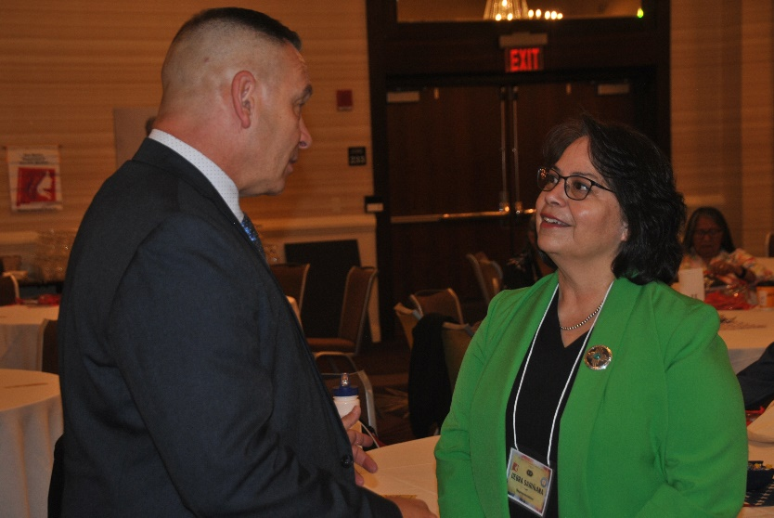

Conference attendees were also able to stop by more than two dozen informational tables before the conference and during breaks.

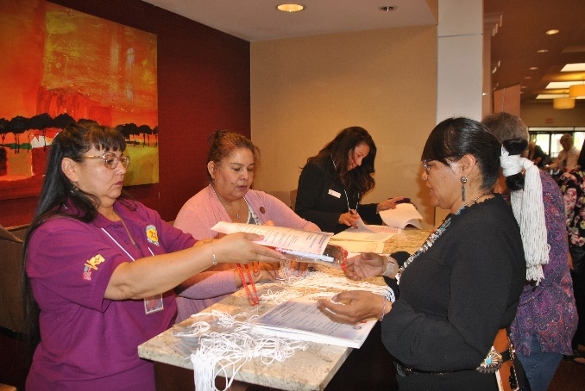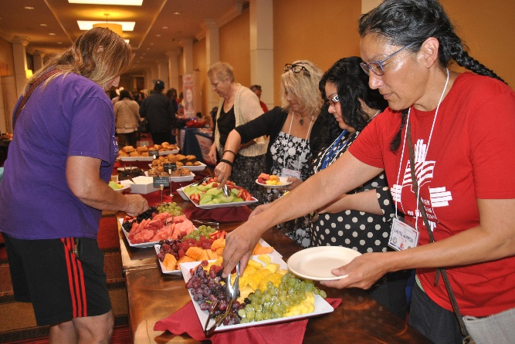

DVS Executive Assistant to the Cabinet Secretary Shannon Quintana (far left), DVS HR Specialist Lori Gutierrez (in light pink sweater), and DVS Chief Financial Officer Danelle Lucero (center/top) helped check in conference attendees.

A continental breakfast (pictured) and a plated enchilada lunch were also provided to all attendees.

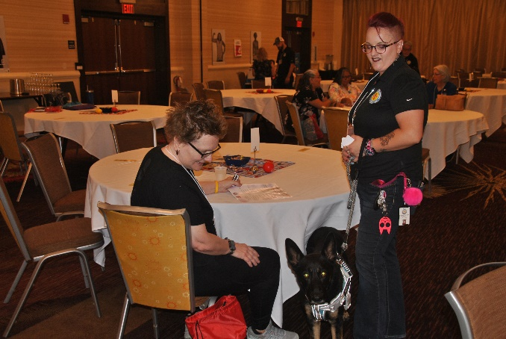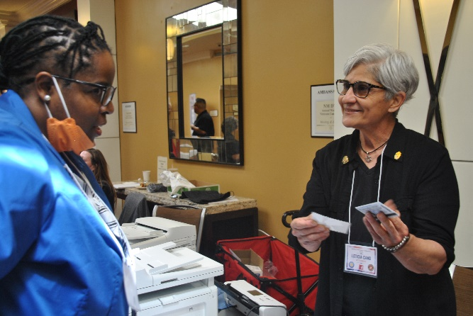

DVS Taos-based VSO Lety Cano *(at right).*

Several DVS staff attended the conference to answer questions and make appointments with veterans. Pictured here is Roswell-based Veterans' Service Officer Danielle Thompson *(standing)* and her emotional support dog Maddox.

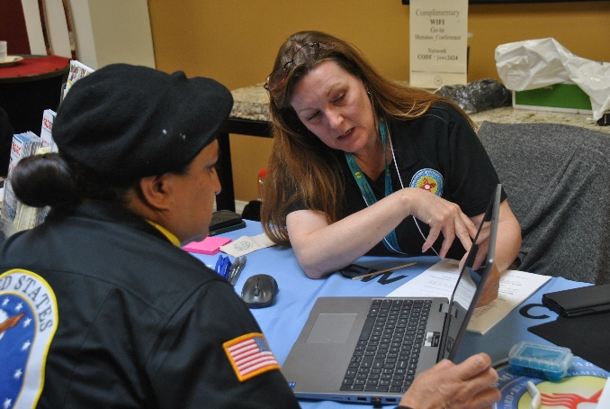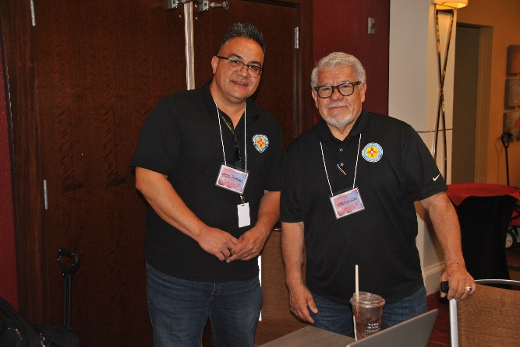

DVS Albuquerque Metro Area VSO Supervisor May Chavez *(at right)*

**(L to R):** DVS Southwest Region VSO Supervisor Miguel Garcia and DVS downtown Albuquerque-based VSO Ronn Saavedra.

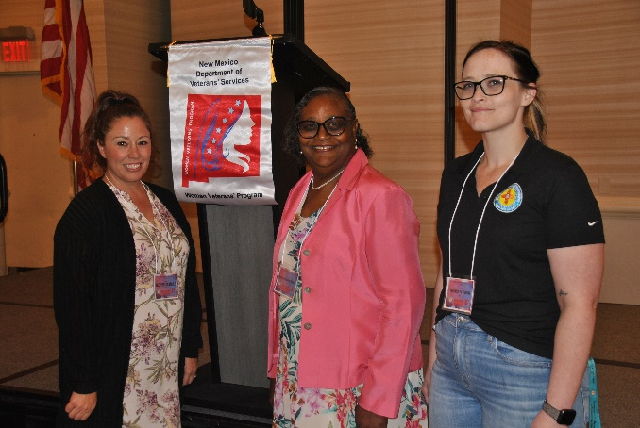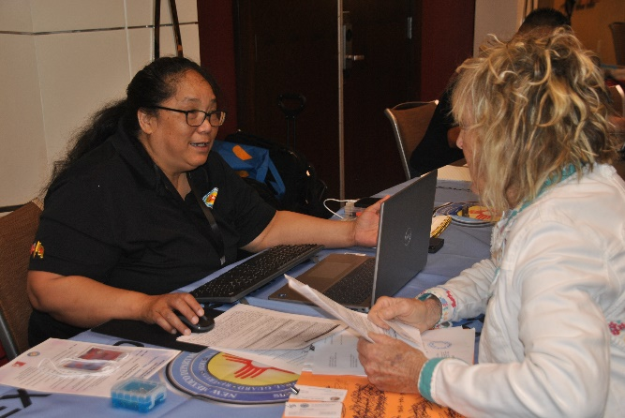

**(From L to R):** DVS Health Care Coordination Division Social Worker Therese Castillo, DVS Health Coordination Director Diane Mourning Brown, and DVS Health Care Coordination Division Assistant Veronica Patterson.

DVS Grants/Cibola County-based VSO April Ball *(at left)*

###