**80th Anniversary of “D-Day”**

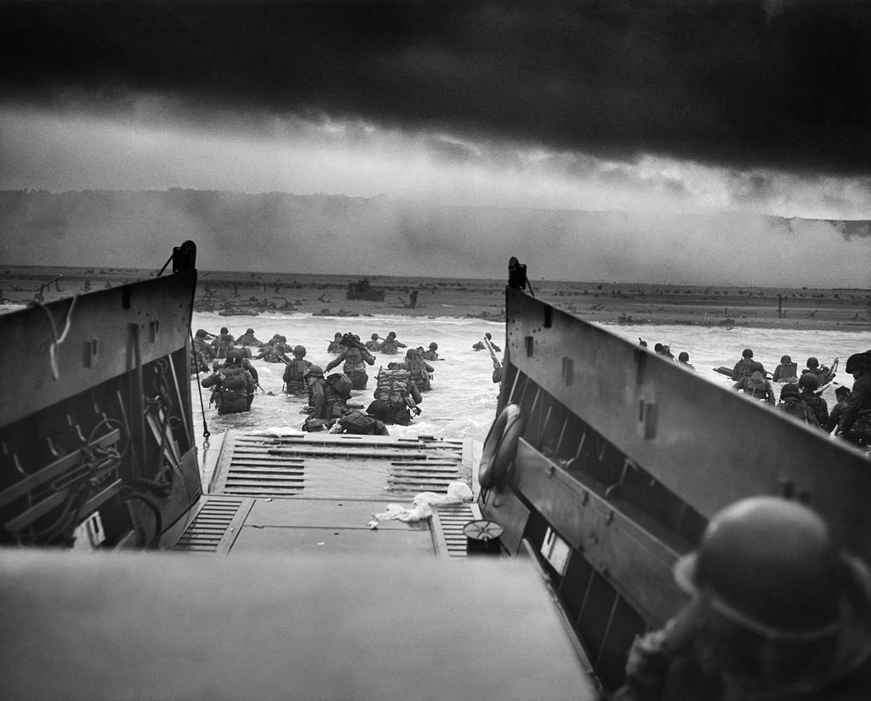

Eighty years ago, on this date…June 6, 1944…American, British, and Canadian military forces combined to launch the largest amphibious invasion force ever assembled in world history. This daybreak assault during World War II was the start of *Operation Overlord,* the Allied battle to recapture western France from Nazi control and ultimately take the battle into Paris. This first day was called D-Day.

Nearly 160,000 Allied troops—73,000 of these American--invaded a 50-mile section of the rugged Normandy coastline, landing at five designated landing points: Omaha, Utah, Gold, Juno, and Sword beaches. They were supported by more than 7,000 ships and 12,000 aircraft which also dropped thousands of paratroopers behind enemy lines.

Inaccurate Allied intelligence reports, an entrenched German force, poor weather, and strong currents made the invasion much more difficult—and costlier--than expected. Many paratroopers were blown off-course—with many killed or taken prisoner. According to U.S. Army records, 4,400 Allied soldiers were killed on D-Day—including 2,500 Americans. Most casualties were on Omaha and Utah beaches, where the fighting was the fiercest.

More than 5,000 Allies were wounded.

The Allies pressed on, suffering additional heavy casualties in the ensuing Battle of Normandy--but making steady progress. The liberation of Paris happened when the Allied finally reached the outskirts of the capital city on August 29, with Allied control secured six days later. From there, it was onward into Germany itself. Allied ground troops crossed into Germany in March of 1945, paving the way for additional major offensive moves as the Allies moved deeper throughout the country. Two months later, Germany unconditionally surrendered on May 7, 1945.

The fall of Nazi Germany was due in large part to those brave men who stared danger in the face when storming the beaches of Normandy. On this 80th anniversary of D-Day, let us remember these heroes—especially those who did not return—who helped bring freedom back to Europe, the United States, and the rest of the free world.

Very Respectfully,

Jamison Herrera  
*Cabinet Secretary, New Mexico Department of Veterans’ Services;*

*Current New Mexico Army National Guard Brig. Gen./Deputy Adjutant General*