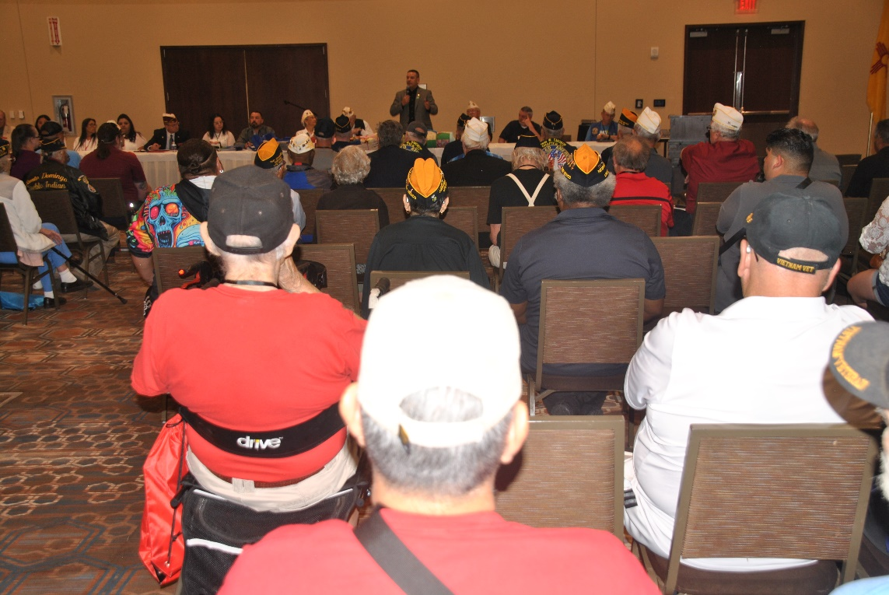
New Mexico Department of Veterans’ Services (DVS) Cabinet Secretary Jamison Herrera was the guest speaker on June 14/opening day of the 2024 annual Disabled American Veterans State Convention at the Isleta Pueblo Resort & Casino in Albuquerque.

Secretary Herrera was asked to provide an update on DVS and statewide veterans’ benefits and programs. One development he said about the addition of five veterans’ service officers (VSOs) being added to the agency in the coming months.
“My goal is to have one VSO in every county,” he said. “I asked for 17, but the legislature approved only five. That’s a start. But I will continue to ask for more for as long as I am the cabinet secretary, because there a lot of veterans in the state that could use our help.”

He also talked about funds coming to the agency to help address the issues of veteran homelessness, and suicide prevention. Secretary Herrera also reminded conference attendees about the two veterans’ property tax exemption and waiver proposals appearing on the ballot in the upcoming November general election. One measure asks voters to approve increasing the veterans property tax exemption to $10,000. The other measure opens up the disabled veterans property tax waiver to veterans with any VA service-connected disabled rating…linking the amount of the waiver to the veteran’s VA disability rating.

Secretary Herrera also briefly touched upon at new 4x4/all-season DVS mobile unit the agency is in the process of purchasing to expand and improve outreach to even the most remote parts of the state. And he mentioned DVS awarded $1.2 million to develop plans for developing plans to build a multiple-agency/one-stop-shop Veterans Resource Center in Albuquerque—to be populated not only by DVS, but also the VA, other state agencies, and many veterans’ service organizations.

Secretary Herrera wrapped up his remarks by urging a greater cooperation between all veterans’ service organizations and community service agencies, pointing out that all have the same goal in mind.
“We’re all here to serve veterans,” he said. “The goal is to help them and their families. We can all do a much better job by working together, by synchronizing our effort and working smarter, not harder.”
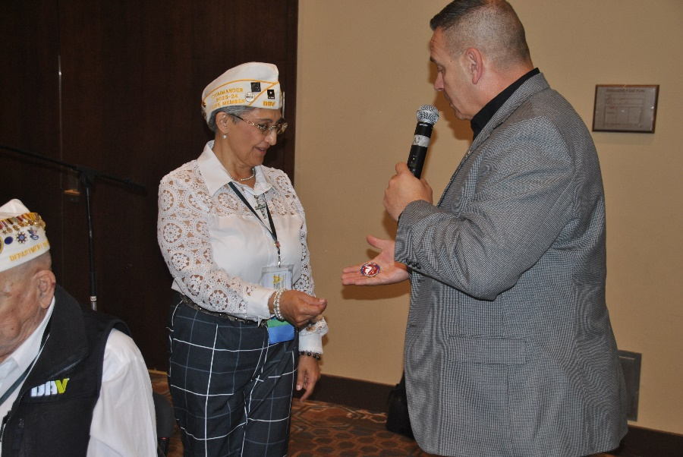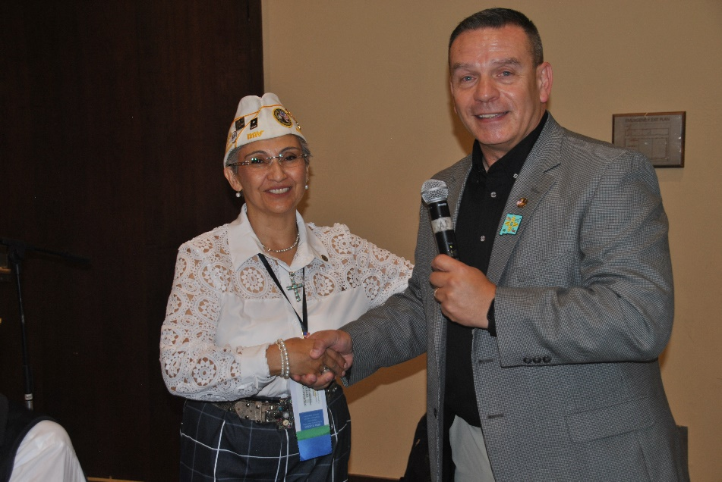

(above two photos: DVS Cabinet Secretary Jamison Herrera presents a DVS Challenge Coin to outgoing DVS State Commander Agnes Cardenas.

###

