DVS Deputy Secretary Eric James *(above photo/center-top, at podium)* took part in a ceremony today honoring a former member of the Daughters of the American Revolution (DAR)/Santa Fe Steven Watts Kearney Chapter featured in an art exhibit in the halls of the Bataan Memorial Building in Santa Fe.

The ceremony was presented by the DAR chapter to honor former member Ramona Baca Latimer. The exhibit honors six unique women who are buried at the Santa Fe National Cemetery. Five of the women are veterans. Latimer was the wife of former WWI and WWII U.S. Army Captain Charles W. Latimer. She had a long history of helping veterans and the Santa Fe community as a whole.

“ Each of these women embodies the spirit of patriotism, service, and dedication to upholding the values that our nation was founded upon,” said Deputy Secretary James. “As we gather here, let us celebrate the significant accomplishments of these remarkable women, and rededicate ourselves to the noble cause of honoring our past while shaping a brighter future for generations to come.”

Ramona Baca Latimer passed away in 1991 and is buried at the Santa Fe National Cemetery beside her husband, who was laid to rest after passing away in 1949.

*(more photos below)*

(ABOVE PHOTO) The exhibit on the wall of the main east-west hallway near the DVS Santa Fe main office inside the Bataan Memorial Building.

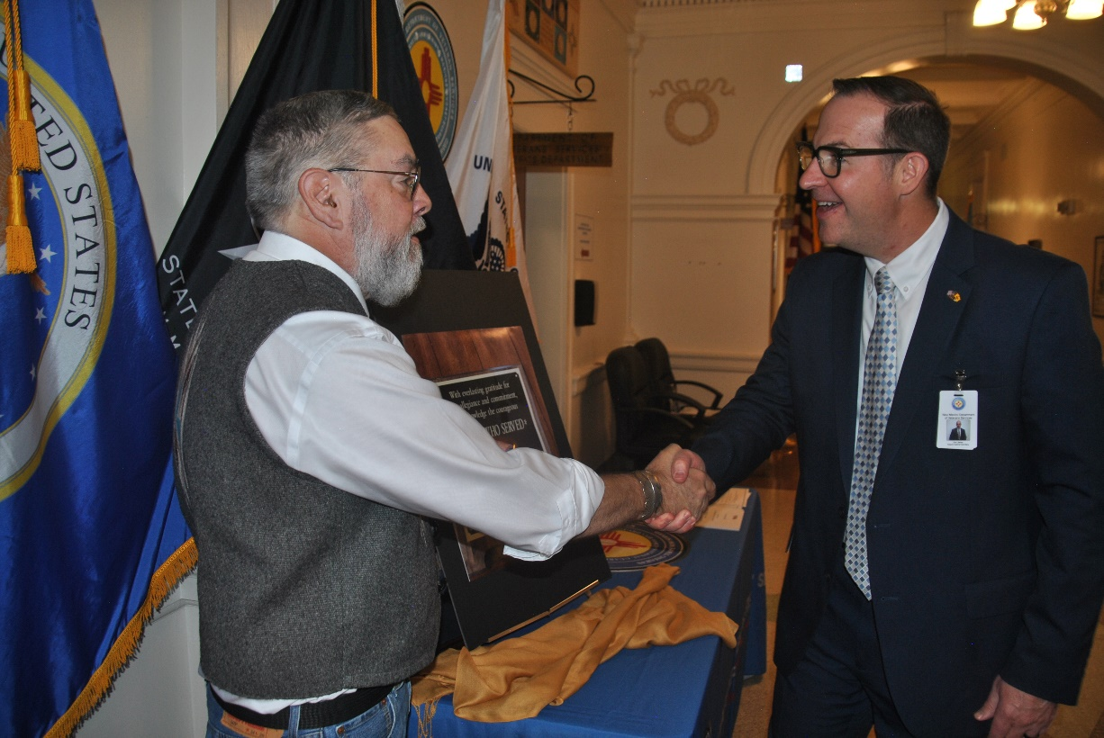

DVS Deputy Secretary Eric James *(on the right)* shakes the hand of Mike Latimer, a grandson of Ramona Latimer, after unveiling a photo of the plaque and poster honoring his grandmother.

DVS Deputy Secretary James, Mike Latimer’s wife Nancy, Mike Latimer, and DAR/Stephen Watts Kearny Chapter Regent Carol Murski. The Latimers flew in from their Florida home for the event.

DVS Deputy Secretary James and Mike Latimer pose in front of the exhibit honoring Mike’s grandmother Ramona Baca Latimer.