New Mexico Department of Veterans’ Services Cabinet Secretary Jamison Herrera greeted more than 300 Run For The Wall motorcycle riders who stopped for the night in Albuquerque on May 16.

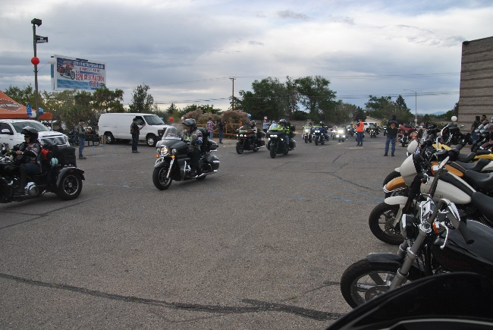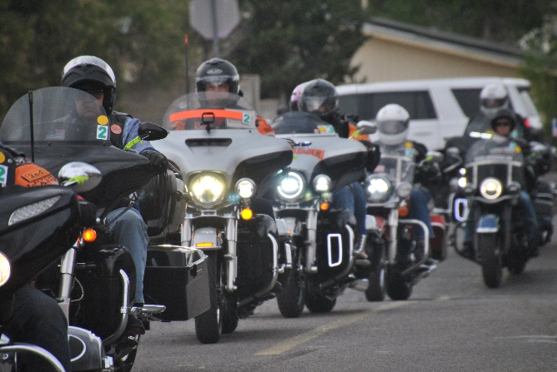

The Run For The Wall is an organized cross-country motorcycle ride that honors our nation’s veterans and their families, while also raising awareness of service members still listed as missing in action.

Riders started the ride, or “run”, yesterday in the southern California city of Ontario. This “Midway Route” is one of three routes that end ten days later at the Vietnam Memorial Wall in Washington, D.C. on Memorial Day Weekend. The two other routes also cross New Mexico in on their way to the Wall.

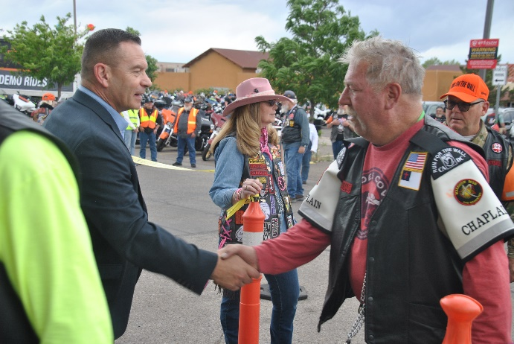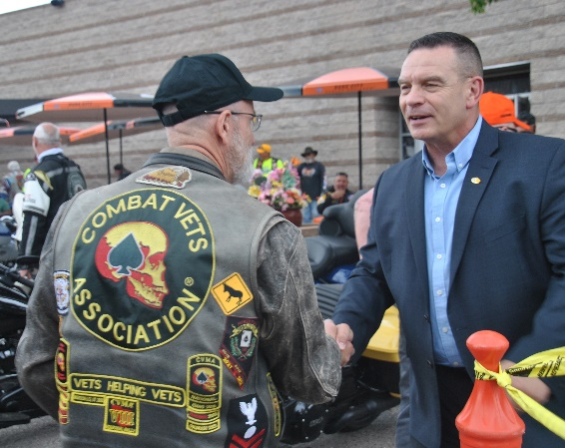

Secretary Herrera met the Midway Route riders when they stopped for dinner at Thunderbird Harley Davidson in the northeast Heights. He thanked veterans making the ride for their service for our country, and praised all riders for their mission of honoring all who served.




