New Mexico Department of Veterans’ Services (DVS) staff attended the 2024 Small Business Administration (SBA)/New Mexico District’s Small Business Awards Breakfast today at the Crowne Plaza Hotel in Albuquerque.

We proudly watched as Chis Sweetin, a 20-year U.S. Air Force veteran and the co-founder/CEO of Triskelion Group of New Mexico, Inc., was honored by the SBA as New Mexico’s Small Business Person of the Year.

Triskelion provides comprehensive security, investigative services, and security training solutions for businesses. Ten years Chris came to the New Mexico Veterans Business Outreach Center (VBOC)—the small business development division of DVS--for help with launching the company as the result of his idea to start a security consulting business. Through the years he has turned to the VBOC for help with growing his company, which now employs 71 people—most of whom are fellow veterans--and provides security solutions for 35 businesses.

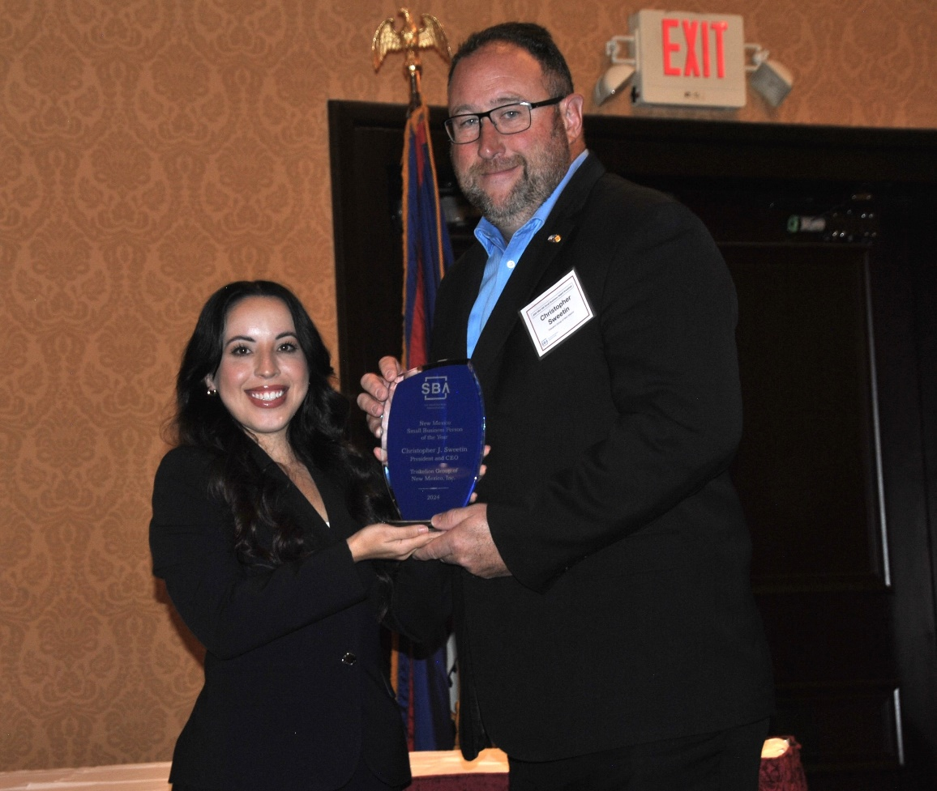

SBA District Six Public Information Officer Abigail Gonzalez presents the SBA’s 2024 New Mexico Small Business Person of the Year award to Triskelion Group Co-Founder/CEO Chris Sweetin.

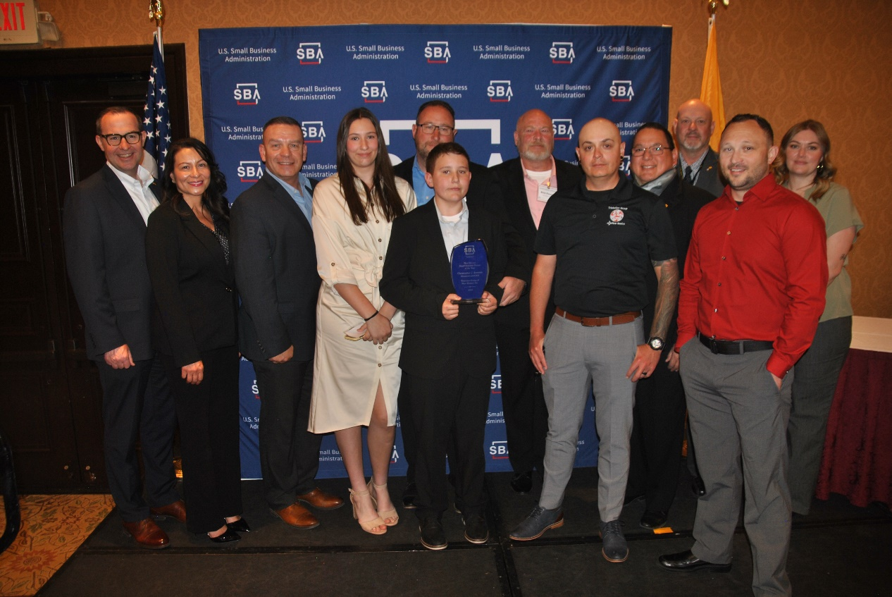
(from L to R): DVS Deputy Secretary Eric James, DVS Chief Financial Officer Danelle Lucero, DVS Cabinet Secretary Jamison Herrera, Katelyn Sweetin (Chris’ daughter),Chris Sweetin, Connor Sweetin (Chris’ son/holding the plaque), Triskelion Director Brian Finucan, Triskelion Director of Guards Chris Byers, VBOC Director Johnny Martinez, VBOC Business Advisor Austin Walker, Triskelion Chief Security Officer James Hults, and VBOC Business Operations Specialist Hope Najera.

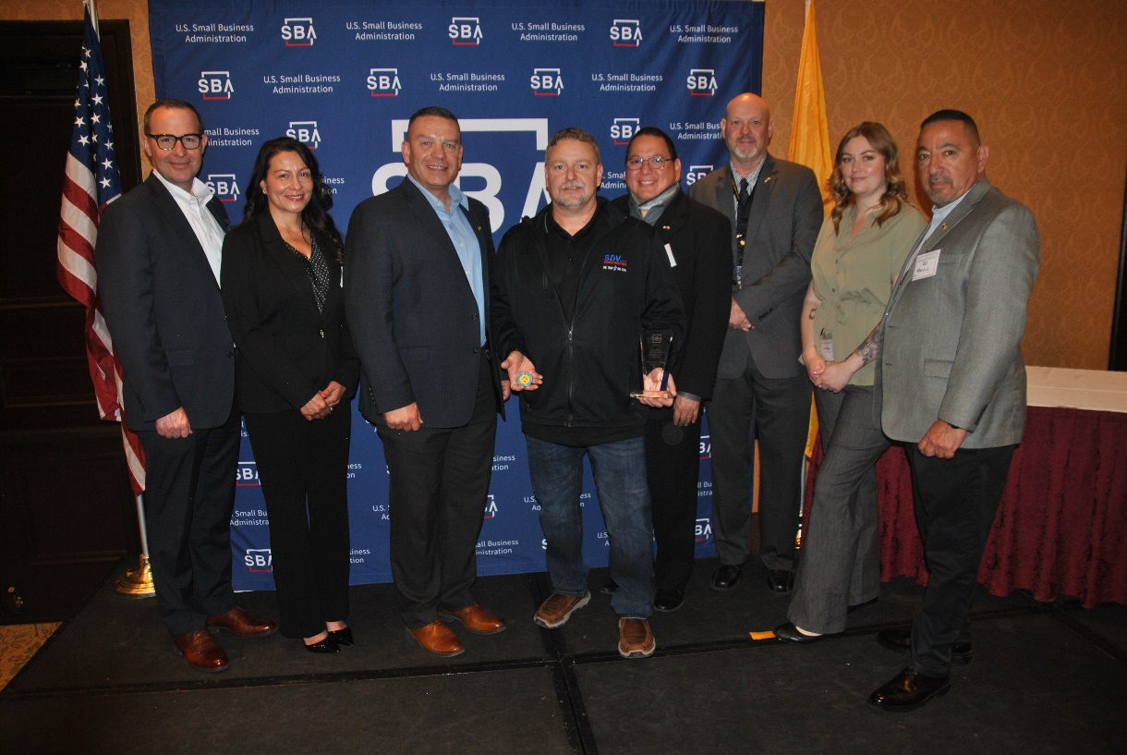
Also honored at the breakfast as the SBA’s veteran-owned small business of the year was William “Paul” Farless, the president & CEO of SDV Construction, Inc. (in the middle, holding the award plaque and a DVS coin presented by DVS Cabinet Secretary Herrera). To the left of Mr. Farless is DVS Deputy Secretary James, DVS CFO Lucero, and DVS Cabinet Secretary Herrera. To the right of Mr. Farless is VBOC Director Martinez, VBOC Business Advisor Walker, VBOC Business Operations Specialist Najera, and DVS State Benefits Director Edward Mendez.

