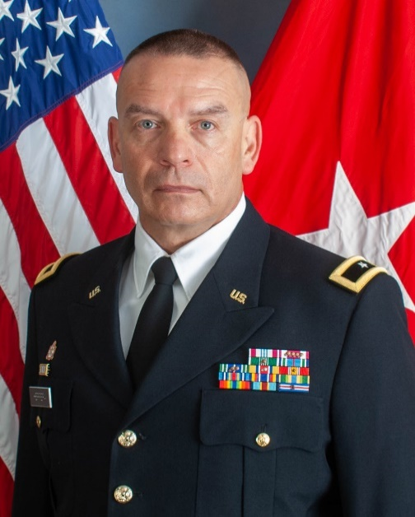
Gov. Michelle Lujan Grisham appointed Brig. Gen. Jamison Herrera as Cabinet Secretary of the New Mexico Department of Veterans’ Services (DVS). Herrera has served as the Acting Secretary of the department since September of last year, while concurrently holding the position of Deputy Adjutant General for the New Mexico National Guard.

“Secretary-designate Herrera has already proven his dedication to military service throughout his more than 34 years in the New Mexico National Guard,” said Gov. Lujan Grisham. “With his extensive military experience, he is well-positioned to advocate for and address the challenges faced by veterans and their families and make sure they receive the services they deserve.”

"I am grateful to the governor for the opportunity to serve New Mexico's veterans, and I'm committed to maintaining the same dedication I've had working with servicemen and women,” said Brig. Gen. Herrera. “I eagerly anticipate building relationships to expand and synchronize veterans' services across the state."

Brig. Gen. Herrera is a native of New Mexico whose parents both served in the U.S. Navy. His father was a Vietnam Veteran. Herrera has completed 34.5 years of service to our state and nation. He enlisted as a Private First Class in 1989 as a member of the 515th Maintenance Battalion in Santa Fe and went on to receive his commission through the Officer Candidate School class 33-91. He is currently assigned as the Deputy Adjutant General and the Land Component Commander of the New Mexico National Guard.

He holds a Bachelor’s of University Studies with emphasis in Education from the University of New Mexico and a Master’s in Strategic Studies from the United States Army War College. He was awarded an Executive Certificate for completing the General and Flag Officer Homeland Security Executive Seminar, May 2023 at Harvard University’s John F. Kennedy School of Government.

