New Mexico Department of Veterans’ Services (DVS) Secretary-Designate Jamison Herrera was unanimously confirmed by the New Mexico Senate on February 11 as DVS cabinet secretary. The current New Mexico Army National Guard brigadier general had been serving in the acting capacity since being selected last September by Governor Michelle Lujan Grisham to fill the vacant position.

"Brig. Gen. Herrera has already demonstrated an unparalleled commitment to military service,” said Gov. Lujan Grisham. “The Senate's unanimous confirmation speaks to his ability to tackle the issues affecting veterans and to ensure they receive the services they deserve."

“Brig. Gen. Jamison Herrera has over 34 years of military service to the New Mexico National Guard. He is a man all about service and serving,” said State Sen. Harold Pope, Jr., a U.S. Air Force veteran who sponsored Secretary Herrera’s nomination in the senate. “New Mexico’s veterans will now have a secretary undergoing a transition to civilian life himself, one who understands what enlisted troops have been through because he’s been there, and one who understands the sacred promise New Mexico has to take care of our
veterans. I look forward to working together with DVS to carry their mission forward.”

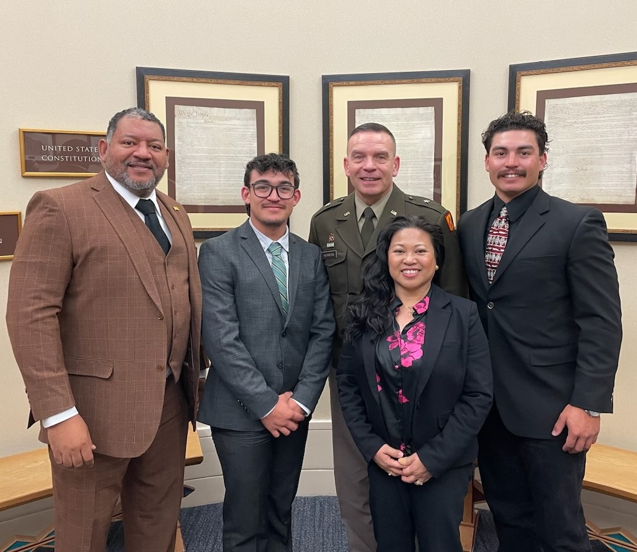

DVS Secretary Jamison Herrera (2nd from right) moments after his unanimous confirmation in the state senate on February 11. With him is State Sen. Harold Pope (far left). In front of the secretary is his wife Ellen. Flanking him are his sons Nick (2nd from left) and Jason. . Flanking him are his sons Nick (2nd from left) and Jason.
Secretary Herrera’s parents both served in the U.S. Navy. His father was a Vietnam veteran. The native of Nambe in northern Santa Fe County has completed nearly 35 years of service to our state and nation. He enlisted in the New Mexico Army National Guard as a private first class in 1989 as a member of the 515th Maintenance Battalion in Santa Fe, and earned his officer’s commission through the Officer Candidate School class 33-91.

The secretary earned a Bachelor’s of University Studies with emphasis in Education from the University of New Mexico, and a Master’s Degree in Strategic Studies from the United States Army War College. He was awarded an Executive Certificate for completing the General and Flag Officer Homeland Security Executive Seminar in May, 2023, at Harvard University’s John F. Kennedy School of Government.

“I am grateful for the opportunity to lead the dedicated people of our department in enhancing veterans' services,” said Secretary Herrera, who is also the deputy adjutant general of New Mexico. “I am committed to working tirelessly to foster a network of understanding and ensure the veterans of New Mexico receive the recognition, care, and support they deserve.”

are his sons Nick (2nd from left) and Jason.

