Albuquerque—The New Mexico Department of Veterans’ Services (DVS) has re-opened its downtown Albuquerque office.

The office is located on the third floor of the Dennis Chavez Federal Building, at 500 Gold Avenue SW between 5th and 6th streets.

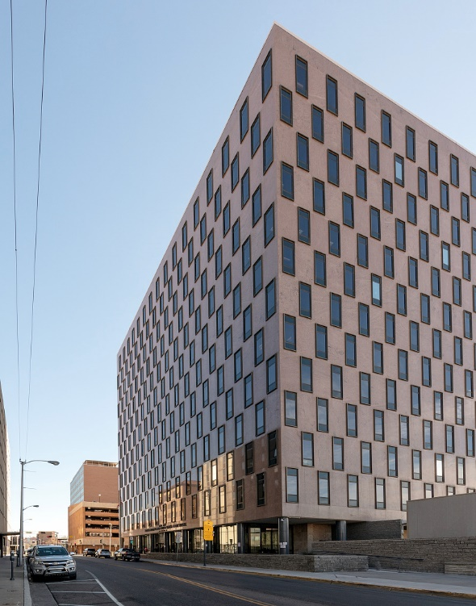

DVS veterans’ service officers will be there Mondays and Wednesdays from 9a.m. – 4p.m. to help veterans or their eligible dependents with filing VA claims, applying for state veterans’ benefits, or assisting with anything else a veteran needs help with. No appointment is necessary. Veterans or dependents will be assisted on a first-come, first-served basis.

“This downtown location provides another easily accessible location for veterans in the Albuquerque metro area to come in and see our veterans’ service officers,” said Acting DVS Cabinet Secretary Jamison A. Herrera. “Please bring your driver’s license or ID card, proof of residency, a copy of your DD-214 separation papers, and any letters or supporting documents from VA so that our VSOs can immediately start working on your case.”

The reopening of the office is the 17th DVS field office in the state—the highest number of offices in the history of the agency. For more information:
dvs.info@dvs.nm.gov or (505) 383-2400.

