The New Mexico Department of Veterans’ Services
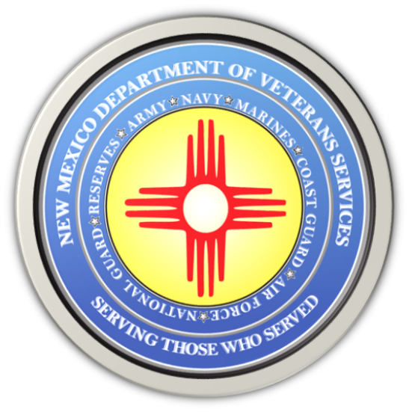

Michelle Lujan Grisham
Governor

Brig. Gen Jamison Herrera
Acting Cabinet Secretary

Two Operation Soundstage Events Next Week

The New Mexico Film Office is hosting two panels next week as part of its Operation Soundstage program to connect with and hire veterans in New Mexico for behind-the-scenes jobs in the state’s booming film and media production industry through training opportunities and discussions.

Below-the-Line Careers for Veterans Tuesday, November 28 (1 p.m.)
Downtown Santa Fe (Jean Cocteau Cinema/418 Montezuma Ave)
Below-the-Line veterans panel will be designed to inspire those who may have transferrable skills and interested in the technical side of the film and television industry to learn about the industry with the goal of joining the union. This will be moderated by SAG-AFTRA Vice-President Talia Pura with veterans and producer and cinematographer Mike Miller and Art Director Jim Twocrow…plus additional panelists. Click here to register.

Acting for Veterans Panel Wednesday, November 29 (5pm)-Virtual Event
The Acting for Veterans panel is for those interested in learning from professionals who are veterans about how to apply their transferrable skills into the acting field with the goal of joining SAG-AFTRA. Moderated by Sheila Ivy Traister with Rik Deskin, Rob Estrada, Bodhi Rader, Zeke Alton, Linsay Rousseau, and Ryan Begay. Click here to register.

More information can be found on the Operation Soundstage website.

Operation Soundstage
Operation Soundstage (OSS) is the result of a multi-state agency partnership between the New Mexico Film Office, the New Mexico Department of Veterans’ Services, and the New Mexico Department of Workforce Solutions to increase the hiring and training of veterans for jobs in the state’s fast-growing film and television production industry.

Veterans with transferrable skill sets interested in training to advance in a specific craft department are strongly encouraged to attend the above events, and to frequently monitor the OSS website for future events and training opportunities.

###

