The New Mexico Department of Veterans’ Services
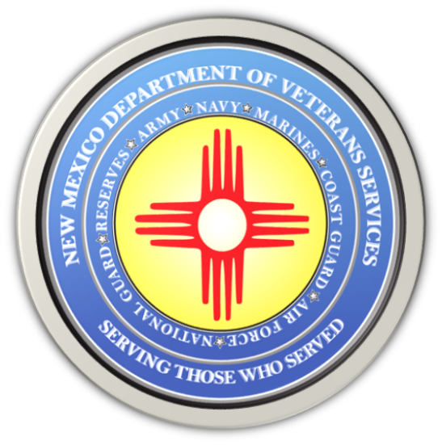

Michelle Lujan Grisham
Governor

Brig. Gen Jamison Herrera
Acting Cabinet Secretary

Two Groundbreaking Women Officers and Two Famed Units to be Inducted into the New Mexico National Guard Hall of Honor

Public is Invited to Attend This Special Ceremony/Dinner

Saturday, November 11 (5 p.m.)
Downtown Albuquerque/Clyde Hotel
330 Tijeras Ave. NW

ALBUQUERQUE-- The New Mexico National Guard cordially invites New Mexicans to the Fifth Annual New Mexico National Guard Hall of Honor Induction Ceremony on Saturday, November 11, at the Clyde Hotel in downtown Albuquerque.

This year’s ceremony will induct the first two females in the Guard’s Hall of Honor, along with two of the Guard’s storied combat units:

Maj. Antoinette Baca
Appointed as assistant adjutant general in 1921, Maj. Baca’s appointment happened long before a 1956 law signed by President Dwight D. Eisenhower allowed women to join the National Guard as medical officers. The following year, the National Guard formally recognized its first woman to join the Army National Guard.

Brig. Gen. Judy Griego
Brig. Gen. Griego was the first female general officer in the history of the New Mexico National Guard. In 2011, then-Colonel Griego became the first woman promoted to the rank of general in the New Mexico National Guard. After retirement from service, Brig. Gen. Griego was appointed as the first woman DVS cabinet secretary.

1st New Mexico Cavalry
Organized on May 31, 1882, by consolidation of the 1st, 2nd, 4th, and 5th Regiments of New Mexico Infantry, the 1st Cavalry fought in New Mexico and Arizona and was one of the founding units of the New Mexico National Guard.

188th Tactical Fighter Squadron
These airmen were the only New Mexico unit to deploy during the Vietnam War as the 188th Tactical Fighter Squadron. The squadron came from the 188th Fighter Bomber Squadron, which was federally recognized in July of 1947, as the inaugural unit in the New Mexico Air National Guard.

“This very special Veterans Day evening is open to anyone who would like to honor these special military giants,” said Brig. Gen Jamison A. Herrera, the deputy adjutant general of New Mexico and the acting cabinet secretary of the New Mexico Department of Veterans’ Services. “It is also a great opportunity to learn more about the New Mexico National Guard’s history and legacy of honor, and to enjoy the company of fellow soldiers, airmen, and veterans.”

A pre-ceremony social hour starts at 5 p.m., followed by the ceremony and dinner at 6 p.m. Ticket prices are as follows:

Open seating:
- Civilians, non-NMNG veterans $75 per person
- E6-E7, CW2-CS3, and O2-O3 $50
- E8+, CW4+, and O4+ $75
- All other military personnel,
and minors $25

Tables can be purchased, with reserved/assigned seating
- Current NMNG personnel $750
- All others $1,000

This is a formal-attire event (ASUs with Bow Tie, Dress/Semi-Formal Blues, and Mess Dress)

For more information and to make reservations, refer to the flyer below:

