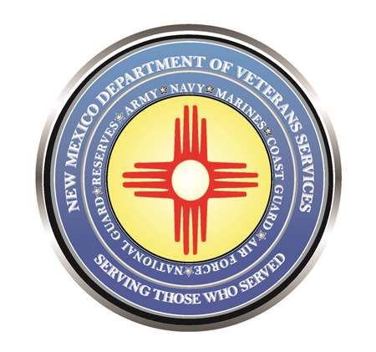

Michelle Lujan Grisham
Governor

Brig. Gen. Donnie Quintana
Acting Cabinet Secretary

DVS veterans’ service officers are scheduled to make veterans benefits outreach stops in October at the locations listed below.

Veterans or their eligible dependents can drop by to get information about or help with filing VA claims, applying for state veterans benefits, or assistance with any other issues a veteran needs help with. Please bring a copy of your DD-214, which is necessary for filing all veterans’ benefits claims.
Date | Location | address | time
Oct. 5 | Capitan/Capitan Public Library | 101 East 2nd Street | 9:30am-3pm
Oct. 5 | Silver City/Dom. Violence Task Force | 315 North Hudson St. | noon-1:30pm
Oct. 11 | Deming/Veterans Food Bank | 4045 Overhill Dr. NW | 10am-2pm
Oct. 11 | Santa Rosa/David J. Flores Veterans' Center | 720 Lake Drive | 10am-2pm
Oct. 17 | Grants/American Legion Post 80 | 121 Third St. | 6-8pm
Oct. 18 | Angel Fire/Nat'l Veterans Wellness & Healing Center | 58 Ash Mountain Loop | 11am-1pm
Oct. 18 | Grants/VFW Post 3221 | 1408 Johnson St. | 6-8pm
Oct. 18 | Ft. Bayard/Ft. Bayard Medical Center | 41 Fort Bayard Rd. | 10:30am-noon
Oct. 19 | Eunice/Eunice Public Library | 1003 Avenue N | 8:30-11:30am
Oct. 19 | Jal/Jal Public Library | 100 East Utah Ave. | 1-3pm
Oct. 25 | Deming/Senior Center | 800 South Granite St. | 10am-12:30pm
Oct. 26 | Lovington/Lovington Public Library | 115 Main St. | 8:30-11:30am
Oct. 26 | Tatum/Tatum Community Library | 23 East Broadway | 1-4pm
Nov. 1 | Ruidoso Community Center | 501 Sudderth Rd. | 9:30am-3:30pm

As a reminder, veterans or their eligible dependents can always make an appointment with any VSO at any of the 16 DVS field offices for in-office or virtual assistance.

###

