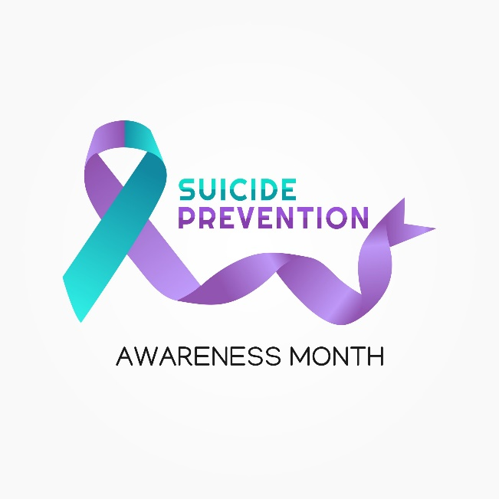

September is National Suicide Prevention Month. DVS urges veterans who are having thoughts of suicide to immediately call the National Suicide & Crisis Lifeline three-digit number: 9-8-8… then press option “1” to be immediately connected to a crisis specialist specifically trained to work with veterans. These specialists can refer veterans to an immediate source in a veteran’s home area.

Family or friends of an at-risk veteran can also call for immediate guidance/help.

According to the 2021 National Veteran Suicide Prevention Annual Report, although the veteran suicide rate decreased in 2019 (the latest year for collecting such data), the suicide rate among veterans was still 52% higher than non-veteran adults in the U.S.

VA has made great strides in veteran suicide prevention, but much work remains to be done. Here in New Mexico, veterans who are not in an immediate crisis but feel they can benefit from ongoing VA counseling can call any of the four VA-managed Vet Centers for help:
--Farmington (505) 327-9684
--Santa Fe (505) 988-6562
--Albuquerque (505) 346-6562
--Las Cruces (575) 523-9826

