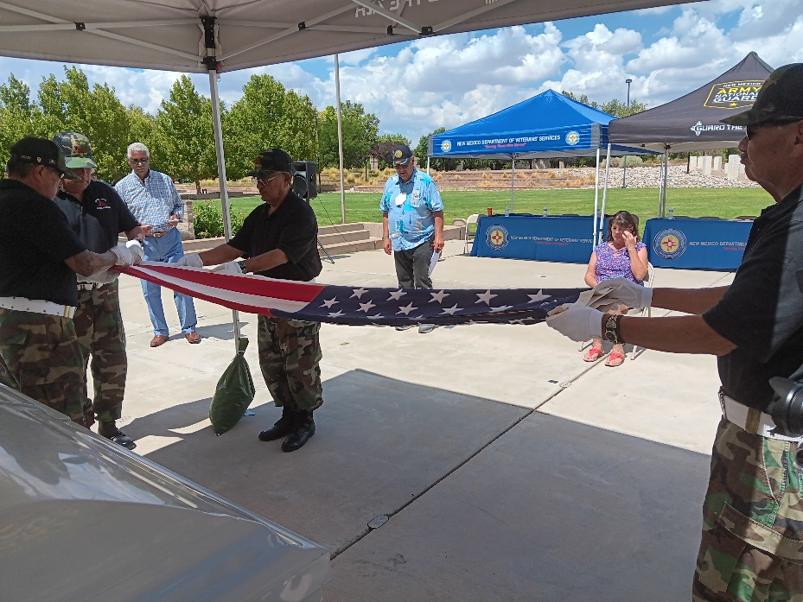

DVS has produced a five-minute video highlighting the 2023 New Mexico Summer Honor Guard Training Conference presented on August 25 at the New Mexico Veterans’ Memorial in Albuquerque.

The video shows highlights of the attending all-volunteer honor guards rendering military honors at mock funerals—under the watchful eyes of judges, who graded the performances and selected the top three performances.

