The New Mexico Department of Veterans’ Services
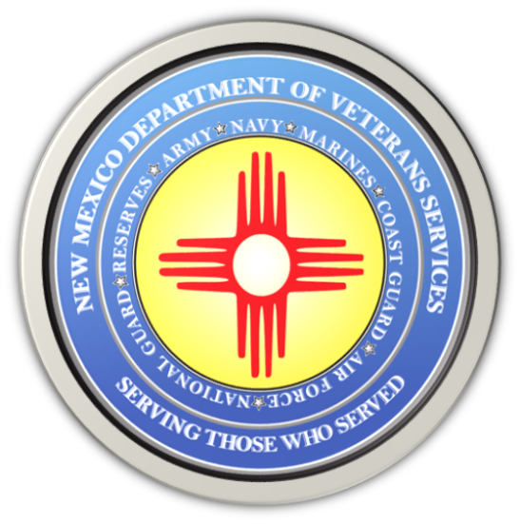

Michelle Lujan Grisham
Governor

Donnie Quintana
Cabinet Secretary

VA Extends Deadline to File for PACT Act Backdated Benefits
Veterans can contact DVS for filing assistance

The U.S. Department of Veterans Affairs (VA) has extended the deadline for veterans and survivors applying for PACT Act backdated claims benefits to Monday, August 14, at 9:59 p.m. Mountain Standard Time.

The PACT Act is the federal law signed by President Joe Biden last year that opens up VA health care for veterans who may be suffering from health issues they believe are linked to service-connected exposure to toxic materials.

Veterans or survivors who apply for PACT Act benefits prior to the deadline extension may, if granted compensation, receive payments backdated to August 10, 2022—when the PACT Act was signed into law. This applies to both claims and Intent to File requests (ITFs).

If approved by VA, backdated payments for disability ratings between 10% and 100% may equate to anywhere from roughly $1,800 to $37,000 in
tax-free money. Those who apply for benefits after the deadline will, if granted compensation, receive payments back to the date of their claim only, which means they will lose eligibility for backdated payments.

Veterans can file either a claim or an Intent to File at VA.gov/PACT.

Posted below this entry on the DVS website is VA Intent to File Form 21-0966. Completed forms can also be emailed to the Albuquerque VA Regional Office via its public contact email address: alb.pctc@va.gov.

How to Complete the VA Form 21-0966:
- Complete blocks 1-18. If a veteran is completing the form, he/she need not complete items 10-18.
- Select Compensation (monthly payments based on disability), Pension (monthly payments based on income), or Survivor’s benefits.
  - If veterans intend on filing claims for specific disabilities, select “Compensation.”
- Sign the form… block 20
- Include date…block 21

New Mexico Department of Veterans’ Services veterans’ service officers (VSOs) are available over the next three business days to assist veterans with filing a PACT Act claim or an ITF.

“If you feel overwhelmed by the filing process, please give us a call,” said DVS Cabinet Secretary Donnie Quintana. “We will help you. We will work line-by-line with you to make sure you accurately fill out the claim. If you’ve been denied before, we can now re-file a new claim. We will also continue to work past the backdate deadline to help toxics-affected veterans file for the VA health care they’ve earned and are finally able to receive.”

Go to the DVS website at https://www.nmdvs.org/new-mexico-offices/ for the locations of DVS statewide offices to make an appointment. You can also call (505) 383-2400 to make an appointment on Thursday & Friday, August 10-11; or Monday August 14…or if you need phone assistance if you’re self-filing.

