Today is National Korean War Veterans Armistice Day, the day when our nation commemorates the signing of an armistice to end the Korean War, and honors our service members who served during the war.

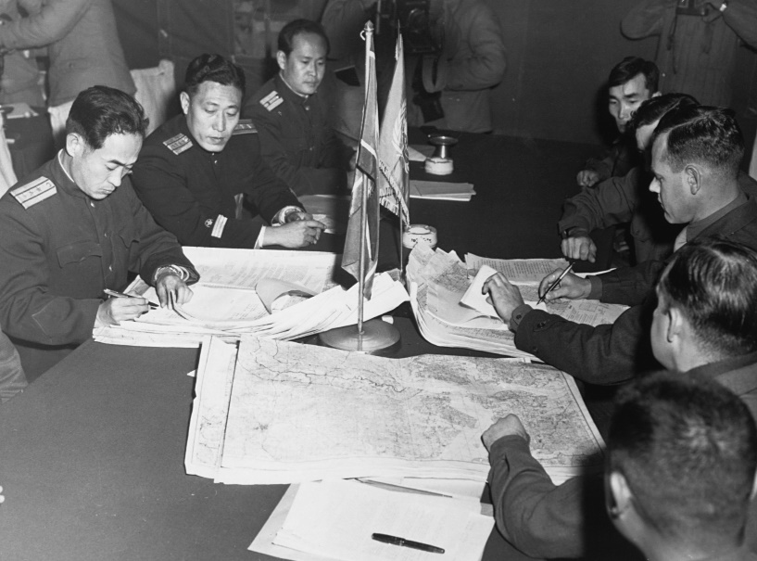

This year marks the 70th anniversary of the signing. On July 27, 1953, the United States of America, which was also representing the United Nations Command (UNC); South Korea, North Korea, and China signed an armistice to bring an immediate cease fire to the three-year-old Korean War. The cease fire also called for the nations to draft a peace treaty to formally end the war.
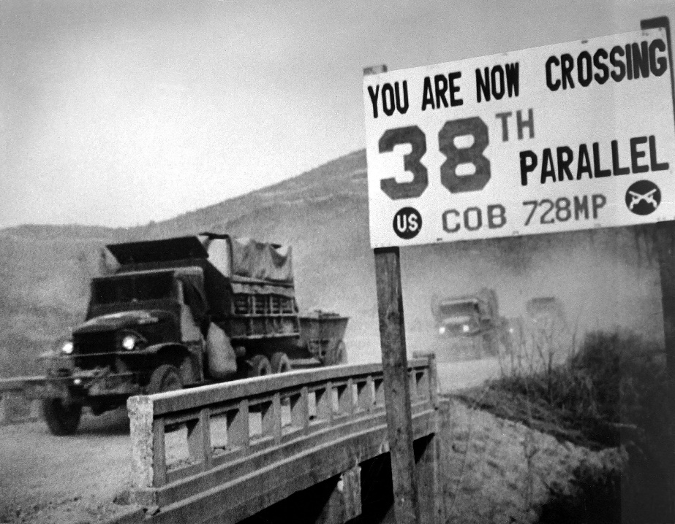

Seventy years later, an official peace treaty has yet to materialize. North and South Korea technically remain at war. A heavily fortified demilitarized zone was built along the 38th parallel. Today tensions remain high between the two Koreas—and between North Korea and the United States.

One way to understand a war is to look at its veterans. Often referred to as the “Forgotten War”, understanding the Korean War veteran’s difficult journey into war and returning home speaks to key themes of the war, and can help take the true measure of the war’s place in American history.

Those who served in the Korean served at a time when Americans were still weary of the global scale of World War II, which ended just five short years before the start of the Korean War. Hostilities began on the Korean Peninsula on June 25, 1950, when communist North Korea invaded democracy-ruled South Korea. It soon involved into the United States supporting South Korea, and China supporting North Korea.

More than six million Americans served during the Korean War era, as tensions again ramped up in a precursor to “the Cold War.” 25,000 New Mexicans served in the war. More than 1.7 million Americans served “in-theater.” 33,700 American service members were killed in action—including 200 from New Mexico. 103,000 were wounded.

More than 7,000 Americans are still listed as missing in action and unaccounted for—including 44 New Mexicans.

Americans should take a moment to honor our Korean War veterans for their service and sacrifice for this war. It is a mistake to refer to the Korean War as the “forgotten war.” Doing so disrespects those who served in the war--and especially those who paid the ultimate sacrifice and never came home. Our Korean War veterans should be remembered and honored as defenders of democracy, who dutifully responded to serve when our nation came calling for their service. Thank you, Korean War veterans, for your service and sacrifice for our country.

--Col. Donnie Quintana (NM Army National Guard-retired)
Cabinet Secretary,
the New Mexico Department of Veterans' Services

