The New Mexico Department of Veterans’ Services
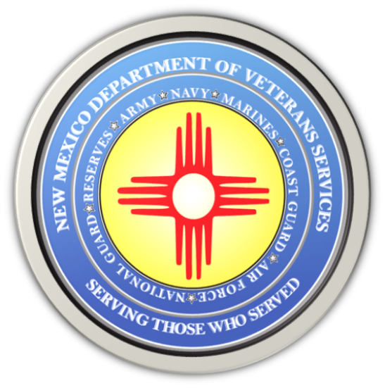

Michelle Lujan Grisham
Governor

Donnie Quintana
Cabinet Secretary

NEWS RELEASE
Contact: Ray Seva
DVS Public Information Officer
ray.seva@dvs.nm.gov
(505) 362-6089

XXXXXX, 2023

Headline
City/Venue (address)
Time of event

DVS is proud to announce two new art exhibits at the Bataan Memorial Building in downtown Santa Fe that honor women veterans.

The “Proudly She Served” national art exhibit is now on display in the east-west hallway of the venerable building. Artist Steve Alpert has painted twelve 36”x30” oil portraits showcasing women veterans who have demonstrated courage, strength, and selfless service for our country.

A second separate exhibit in the same hallway, courtesy of the Santa Fe Community College Veterans Legacy Grant Program, features six unique women veterans interred at the Santa Fe National Cemetery.

