The New Mexico Department of Veterans’ Services
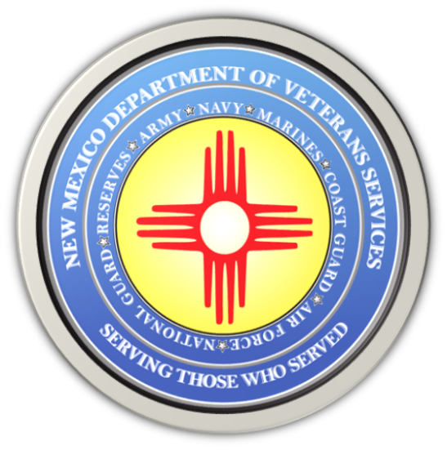

Michelle Lujan Grisham
Governor

Donnie Quintana
Cabinet Secretary

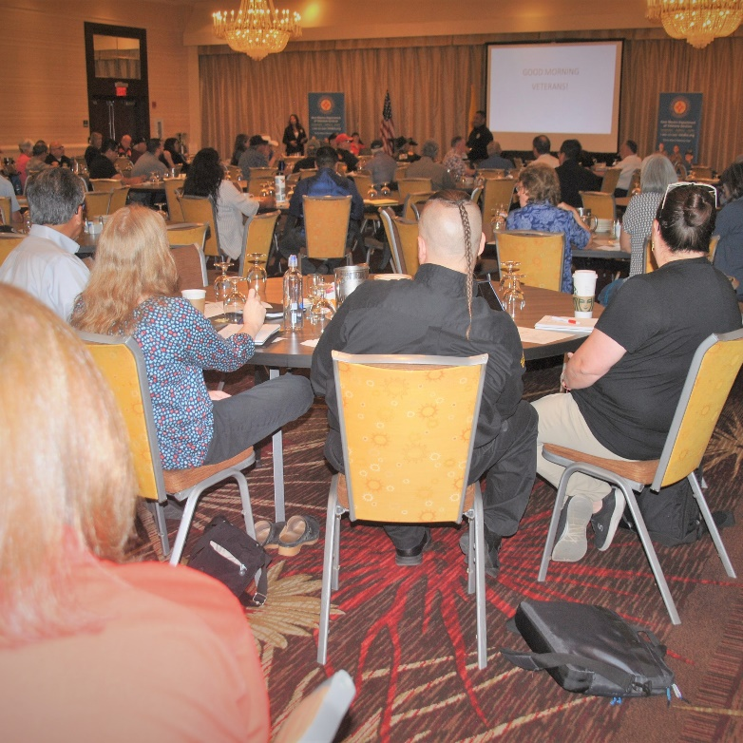

The New Mexico Department of Veterans’ Services (DVS) received a lot of input & feedback from veterans and agency representatives attending today’s Listening Session in Albuquerque.

“I challenge you all. We want to be your megaphone,” he said during a lengthy “open mic” session. “What do we need to do? Who do we need to talk to--the governor? Our legislators? Our congressmen and women? Your local governments? Whoever. Whatever. Talk to us. Let us know what you’d like for us to do. We want to be your voice.”
Among the topics brought up that led to lengthy discussions were:

• VA says there are 140,000+ veterans in NM, but only 60,000 are registered w/VA health care. Will you be making an effort to reach out to those 80,000 unregistered veterans?
• Not every veteran uses or wants VA health care. We need more TRICARE/Triwest-accepted clinics
• Can the state help us tribal and rural areas get our own trained-and-certified veterans’ service officers?

• A call for a statewide “veterans conference” involving state legislators, NM’s congressional delegation, VA leaders, city officials…to discuss homelessness, unemployment, financial help programs.

• Create resource guide listing all VA, state, and local veterans’ and community service agencies

• The need to expand transportation programs…to provide transportation to all counties.
Secretary Quintana ended the session with a promise to discuss with his DVS staff a plan of action to address these points. He also pledged to develop new partnerships or renew relationships with service agencies throughout the state to strengthen services for veterans.




