The New Mexico Department of Veterans’ Services
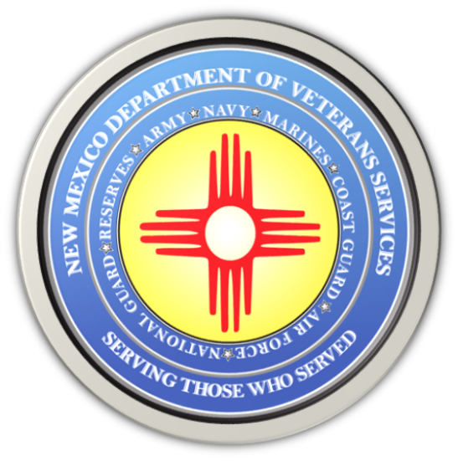

Michelle Lujan Grisham
Governor

Donnie Quintana
Cabinet Secretary

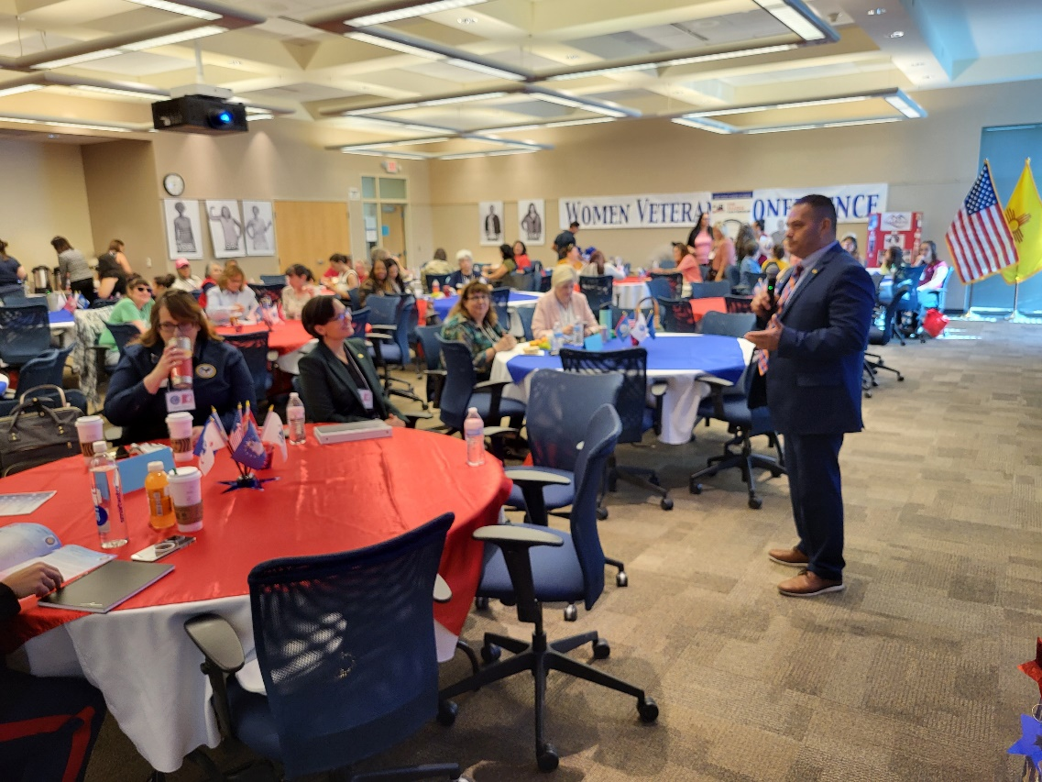
The New Mexico Department of Veterans’ Services (DVS) presented the 2023 New Mexico Women Veterans Conference in Albuquerque today (June 10) at the Central New Mexico (CNM) Workforce Training Center.

The conference was presented two days before National Women Veterans Day—June 12.

Breakfast and lunch were provided, featuring New Mexican fare catered by the venerable restaurant Garcia’s Kitchen.

DVS was joined by representatives from the New Mexico VA Health Care System (NMVAHCS) and the Albuquerque VA Regional Office in presenting information about VA and state veterans benefits available not only to women veterans, but benefits and programs specifically for women veterans.

Women make up the fastest-growing segment of our nation’s veteran population—accounting for about 11% (2,045,000) of our 18.5 million veterans. Here in New Mexico, 16,800 of our state’s 144,100 veterans are women—a little over 11% of the veteran population.

“These numbers are projected to continue to rise every year,” said DVS Cabinet Secretary Donnie Quintan during his welcome remarks (above photo). “It’s our job at DVS to be ready to serve these women…to be ready to help them as veterans—as women veterans.”

Keynote speaker United States Marine Corps Major Mariela Peña urged women veterans not only file for these benefits they’ve earned, but to also believe themselves as women—as women veterans, specifically, and to help out other women.

“I want you to challenge the next crop of women currently serving,” said the native of Nicaragua whose family fled to the United States during the Sandinista-Contra wars. “Reach out to them. Help them if they need help. Inspire them to continue. This is the best way to ensure women continue to succeed not only in the military…but in life afterwards.”

NMVAHCS Director Cesar Romero gave a presentation about the PACT Act—a new law that now opens up VA health care for any veteran who believes their post-service medical issues were caused by exposure to burn pits in Iraq and Afghanistan, Agent Orange in southeast Vietnam –and in other specific locations around the world.
Veterans need not prove this link to their condition—only that they served in one of the regions designated by VA. VA will now presume there is a link and will set you up for an appointment.

He also said since the PACT Act was passed in August of 2022, there have been 2,072 claims filed by New Mexico’s veterans worth $9.6 million.

During lunch, a free-wheeling discussion about their experiences as women officers featured retired Army Maj. Gen. Dee Ann McWilliams, soon-to-retire New Mexico Air National Guard Brig. Gen. Michelle La Montagne, and retired New Mexico Army National Guard Brig. Gen (and former DVS cabinet secretary) Judy Griego.

Amid the stories was a common theme shared by all three: Women need to speak up while in service…and to definitely file for any VA or state veterans’ benefits “because you’ve earned these. Don’t let them go to waste.”

During a presentation about the DVS field services division, Field Services Division Director Robin Wilson talked about a veterans’ service officer training conference she just returned from—and how many there shared stories about many women veterans not considering themselves “veterans.”

“Women veterans will say, ‘I didn’t retire--I only served four years. I got married. I have kids,” she said. “We need to remind women who’ve served: It doesn’t matter. You served our country—you ARE a veteran. You are eligible for VA health care.”

“DVS Women Veterans Program Manager Theresa Figueroa also urged women to get help if they need it—and to offer help to those that do.
Be kind to yourself. Don’t be afraid to ask for help. We’re all going thorough something. Talk to someone. If you give someone hope, you can give them a “re-start.”

NMVAHCS Maternity Care Coordinator Mary Jaco did a presentation about the many women’s reproductive health care programs available through the VA.

In her presentation, she brought up the following information about women veterans nationwide:
- By 2040, women will make up 18% of the vet population
- only 44% of eligible women veterans are enrolled in VA health care.
- Women veterans are younger than male veterans
  - Average age of a male veteran enrolled in VA health care: 65
  - Average age of a women veteran: 51
    - 35-54 is the largest age group

Recognizing this, VA has greatly expanded its care for women veterans. In addition to benefits available for male veterans, VA now offers
- Maternity health care
- Newborn health care
- Post-partum support help
- Various screenings, testing pertinent to unique women’s health needs

“VA wants to make it clear that women veterans are now a main focus of our VA health care,” said Jaco. “But we still need to get the enrollment numbers up. We don’t want to this to develop into a bigger problem. I ask that you help us spread the word.”

U.S. Air Force Tech Sgt. Sheena Hvlicko wrapped up the conference by talking about challenges facing women veterans—and the importance again urging women to believe in themselves “Again…don’t be afraid to speak up. Don’t be afraid to succeed. Believe in yourself--because not believing in yourself is one of the biggest barriers to our successes.

Email the New Mexico Department of Veterans’ Services for more information about topics covered at the conference.

###

