The New Mexico Department of Veterans’ Services
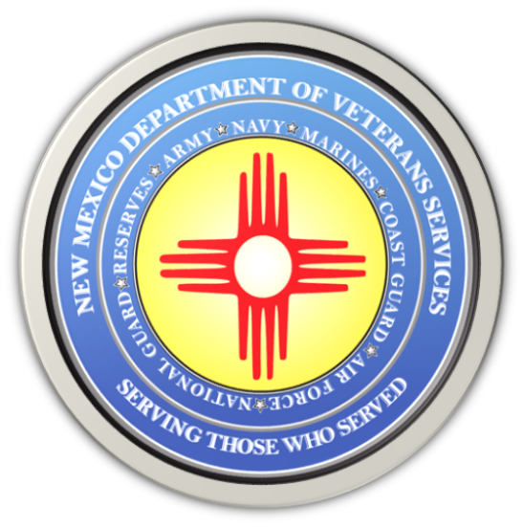

Michelle Lujan Grisham
Governor

Donnie Quintana
Cabinet Secretary

Reminder About the Veterans’ Designation
New Mexico Driver’s License

The New Mexico Department of Veterans’ Services (DVS) is reminding veterans about the veterans designation on a New Mexico driver’s license available to any driving-eligible honorably discharged military veteran.

The veterans designation is clearly marked in red print on the front of the license, making it easier to prove veteran status. Many businesses in the state offer veterans’ discounts to veterans if they show proof of military service.

There is no additional charge for obtaining this veteran’s designation when applying for or renewing the driver’s license. Veterans only need to provide a copy of their DD Form 214 Certificate of Release or Discharge From Active-Duty Form. A VA Health ID card, military retiree or National Guard/DoD active-duty ID card are also acceptable forms to show proof of veteran status.

Veterans still have to pay the normal $18 fee for a four-year license, or $34 for an eight-year license when applying for or renewing a driver’s license, or replacing a lost one at any Motor Vehicle Division or MVD Express office.

“The veteran-designation driver’s license enables veterans to show proof of military service without the inconvenience of bringing copies of their separation papers to a business to get the veterans discount,” said DVS Cabinet Secretary Donnie Quintana. “Veterans often bring their original separation documents with them, so the veteran’s license eliminates this chance of someone losing that original copy.”

More information about the veteran-designation New Mexico driver’s license, please call the MVD at (888) 683-4636.

###

