The New Mexico Department of Veterans’ Services
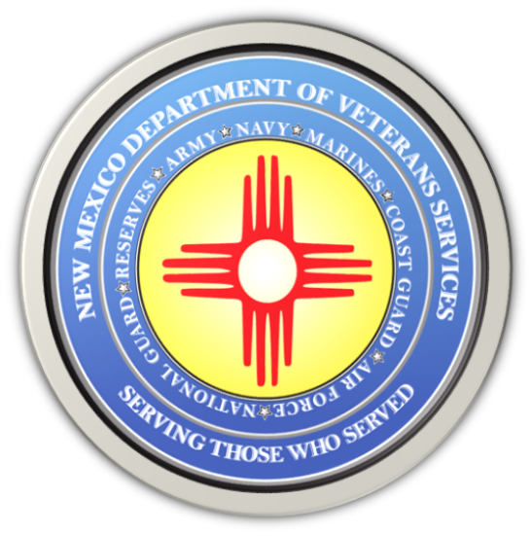

Michelle Lujan Grisham
Governor

Donnie Quintana
Cabinet Secretary

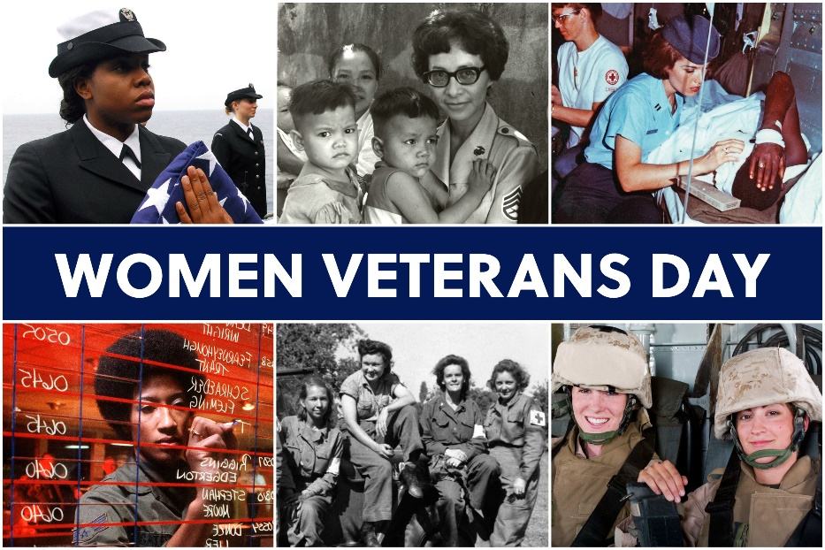

Today is Women Veterans Day, a day where a handful of states across the nation—one of which is New Mexico--have designated as the day to honor the military service of our women veterans.

June 12 is a significant date in the history of our military. On this date in 1948, President Harry S. Truman signed into law the Women’s Armed Services Integration Act that made it legal for women to serve in our military as full-fledged service members.

Prior to this, women could only serve as nurses during peacetime, or just in secretarial, administrative, or other non-combat positions. During our nation’s Revolutionary War, women were known to grab muskets of fallen soldiers or militia members. Many even assisted on cannon units—even though they were primarily tasked with rendering first aid and providing meals.

During our nation’s Civil War, more than 400 women performed the same tasks for both the Union and Confederacy. During World War I, the number swelled to 35,000.

In World War II, nearly 150,000 women provided the same critical support tasks—but expanding their service to now include serving as non-combat Women Airforce Service Pilots (WASPs) carrying out critical supply and training tasks here at home. The Navy created the Women Accepted for Volunteer Emergency Services (WAVES) to fill critical administrative and supply position vacancies here at home due to the deployments by males holding these positions.

Women took on even more responsibilities during Korean War—and by the Vietnam War, 265,000 women served in the military. 11,000 nurses were in Southeast Asia and Asia rendering aid to injured American service members. Eight women in the military were killed during the war. 59 civilian women lost their lives during the Vietnam War.

Today, women are not only serving alongside men in-theater, we now have women officers. Women are now leading men and women. There are now women generals, admirals, fighter pilots, ship captains…and even as 11b infantry.

The contributions of women in our military have been important, and it will only continue to grow. Women make up the fastest growing segment of our active-duty and veteran population. 11% of our veteran population are women. This is expected to grow to 18% by the year 2040.

There are about two million women veterans in American, including 16,800 here in New Mexico—more than 11% of our state’s veteran population. Today is the day New Mexico honors their service. Currently only 13 other states formally honor women veterans on this date: California, Hawaii, Indiana, Kentucky, Michigan, New Jersey, New York, Ohio, Oregon, South Carolina, Tennessee, Texas, and Wisconsin. There have been bills recently introduced in Congress to make this a national day of observance. So far this movement has been slow to take hold.

I’m hoping that the day comes soon that our nation can come together to formally honor our women veterans on this significant day in military history. Yesterday, the New Mexico Department of Veterans’ Services presented the 2023 New Mexico Women Veterans’ Conference in Albuquerque to provide information about VA and state veterans’ benefits available for women veterans. We had a great turnout, and received a positive response.

I want to thank all who attended the conference. I hope you learned valuable information, and enjoyed the company of your fellow women veterans. To all women who are currently serving or have served our country, I thank you for your service and sacrifice.
Col. Donnie Quintana (New Mexico Army National Guard-retired)
Cabinet Secretary,
The New Mexico Department of Veterans’ Services

###

