The New Mexico Department of Veterans’ Services
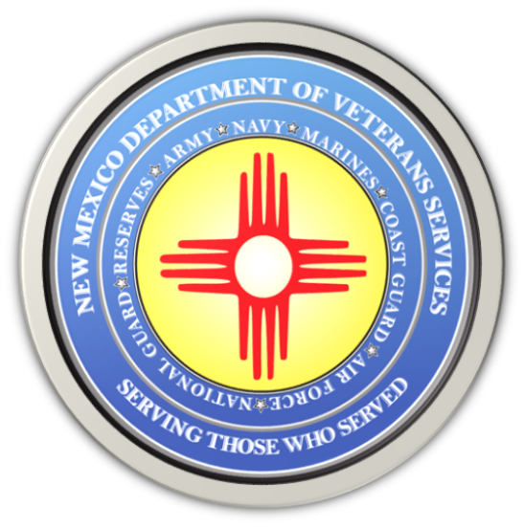

Michelle Lujan Grisham
Governor

Donnie Quintana
Cabinet Secretary

June is National PTSD Awareness Day

June is National Post Traumatic Stress Disorder (PTSD) Awareness Month, and the New Mexico Department of Veterans’ Services is urging veterans who think they may be suffering from post-traumatic stress or are having other behavioral issues to not ignore the signs of PTSD—and get the help they need.

PTSD may develop for anyone who has experienced or witnessed a traumatic event like war. But it can result from non-combat situation domestic incidents such as being a victim of or witnessing a violent physical, sexual, or verbal assault; accidents; or anything else that may be emotionally disturbing.

Symptoms can include depression, anxiety, nightmares, paranoia, insomnia, isolation from family or friends, or having disturbing thoughts. While PTSD is treatable, the lack of knowledge about the condition, and the stigma often attached to anyone seeking mental health assistance, often leads to those suffering from it to ignore the problem and suffer in silence.

According to DVS Cabinet Secretary Donnie Quintana, the key to dealing with PTSD is to focus on activation, not just awareness of the symptoms.

“Though raising awareness is an effective and vital aspect of prevention, any effort must create bridges for people to cross, from awareness to engagement. For many, this bridge is a family member, friend, or co-worker. If you ever suspect that someone may be suffering from post-traumatic stress, please take immediate action and get help right away.”

For immediate help for you or someone you know is having suicidal thoughts or is experiencing mental health-related distress, please call the three-digit Suicide & Crisis Lifeline: 9-8-8…and then press option “1.” A trained veterans’ crisis counselor will put you immediately in touch with someone here in New Mexico who can work with you right there/at the moment.

Veterans who would like non-immediate behavioral and mental health care can call one of the four VA-managed Vet Centers in New Mexico for longer-term, ongoing counseling:
Farmington Vet Center: (505) 327-9684
Santa Fe Vet Center: (505) 988-6562
Albuquerque Vet Center: (505) 346-6562
Las Cruces Vet Center: (575) 523-9826

The New Mexico Department of Veterans’ Services continues to work with the Vet Centers and the New Mexico VA Health Care System to raise awareness year-round about the national suicide and crisis hotline and the Vet Centers.

DVS is also heading up the state’s participation in the national Governor’s & Mayor’s Challenge to Prevent Suicide Among Service Members, Veterans, and their Families—more commonly known as simply “The Governor’s Challenge.”

The agency realizes that mental and behavioral health are not always evident and recognizable, and that many veterans may be suffering all alone and in silence.

“Please—if you even just think you’re suffering from post-traumatic stress, don’t hesitate to get help. This is not the time to be tough, and tough it out like we always did while in service,” said Secretary Quintana, who is a retired New Mexico Army National Guard colonel. “Do it for yourself. Do it for your family and friends. Make that call. It’s the bravest thing you can do.”

###

