The New Mexico Department of Veterans’ Services

Michelle Lujan Grisham
Governor

Donnie Quintana
Cabinet Secretary

The remains of U.S. Army Private 1st Class Thomas V. Long, who perished in a Japanese prison camp during World War II after surviving the infamous Bataan Death March, were finally laid to rest in his hometown of Portales on June 8.

The latest in forensic technology positively identified his remains after they were recently discovered in the Philippines. DVS State Benefits Director Ed Mendez presented a state flag, which was flown in Pfc. Long’s honor on the grounds of the state Capitol, to Jean Sawyer, Pfc. Long’s 96-year-old younger sister (photo below).

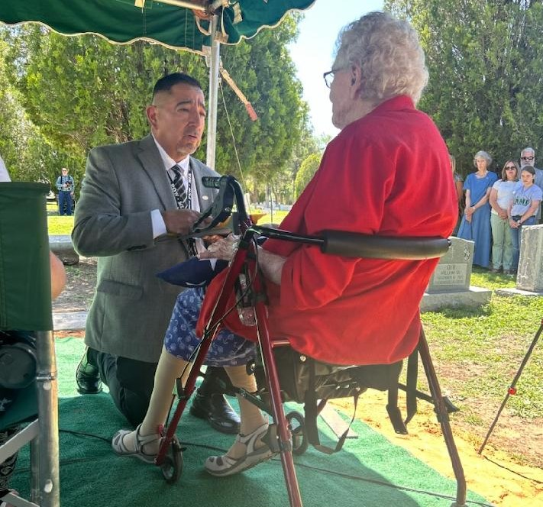

The U.S. Department of Defense had long ago reported that Long died on August 29, 1942. What were believed to be his remains were then shipped back to Portales for burial in the Portales Cemetery. Those originally-buried remains have been exhumed and are now being re-examined for proper identification.

Local blogger Beth Edgeman of “The Crafty Edge”, a grand niece of Pfc. Long, videotaped the re-burial funeral. Here is the link to the video posted on her Facebook page. https://www.facebook.com/search/top?q=the%20crafty%20edge

###

