The New Mexico Department of Veterans’ Services
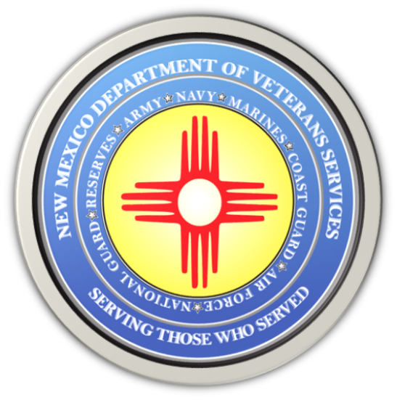

Michelle Lujan Grisham
Governor

Donnie Quintana
Cabinet Secretary

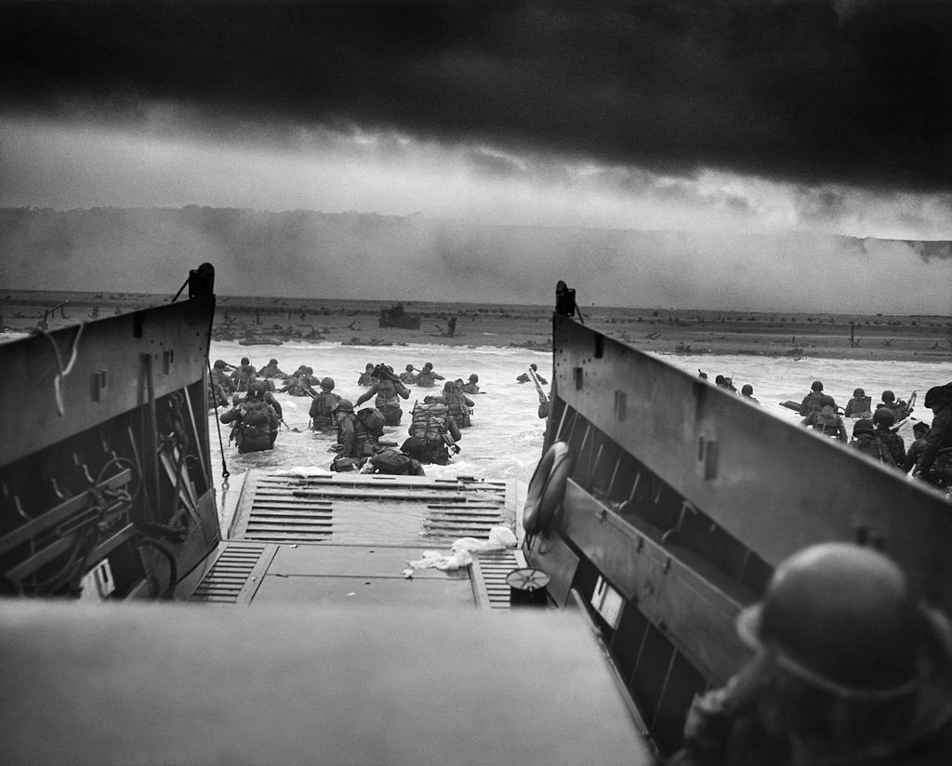
Today is the 79th Anniversary of “D-Day”
Seventy-nine years ago, on this date during World War II—June 6, 1944—American, British, and Canadian military forces combined to launch the largest amphibious invasion force ever assembled in world history.

Operation Overlord was the official codename for this Allied invasion of Nazi-occupied Germany in Normandy, a region in the northwest corner of France about 185 miles across the English Channel from England. But the world has come to know this date as D-Day, the day the Allied forces took the battle directly to Germany—a little over four years after Germany invaded and then occupied France. The time had finally come to mount a major offensive to free France and drive the German occupiers out of the country.

The actual planned date was June 5. But bad weather made General Dwight Eisenhower, the Supreme Allied Commander of the Allied Expeditionary Force, change the date to the following day.

By air and by sea, more than 160,000 American, British, and Canadian troops stormed a 50-mile section of the rugged Normandy coastline on June 6, landing at five designated landing points: Omaha, Utah, Gold, Juno, and Sword beaches. They were supported by more than 5,000 ships and 13,000 aircraft

Faulty Allied intelligence reports, a well-entrenched German force, lingering bad weather, strong winds, and strong currents made the invasion much more difficult than expected—and extremely costly in terms of lives lost. According to U.S. Army records, more than 9,000 Allied soldiers were killed or wounded in the first 24-hours of the invasion—wading onto shore, scaling the German-fortified cliffs behind the beachheads, or shot while parachuting behind the amphibious landing zones. Many paratroopers were blown off-course and were either killed or taken prisoner. It's estimated that 2,500 American service members lost their lives--mostly on Omaha and Utah beaches, where the fighting was the fiercest.

These brave Allied service members, with the odds stacked against them, nevertheless kept moving forward. Despite suffering heavy casualties, they also inflicted equally heavy casualties upon the Germans. The Normandy campaign continued for the next couple of weeks, with Allied forces finally securing the beaches and then advancing into the interior of France. After six days of intense battles, the liberation of Paris happened on August 25, 1944. From there, it was onward into Germany itself. Allied ground troops crossed into Germany in March of 1945, paving the way for additional major offensive moves as the Allies moved deeper into the country.

Two months later, Germany unconditionally surrendered to the Allies on May 7, 1945.

Europe was finally free of Nazi rule—thanks in large part to the brave men who risked their lives who, under heavy fire from a dug-in enemy, stormed the beaches of Normandy to finally take on German forces head-on. During the planning stages of Operation Overlord, General Eisenhower called the invasion a “crusade in which we will accept nothing less than full victory.” Full victory was indeed achieved. But it came at a steep price. Many lives were lost on the beaches of Normandy 79 years ago. Let us always remember the heroes of D-Day, who risked their lives to bring freedom back to Europe, the United States, and the rest of the free world.

Col. Donnie Quintana (NM Army National Guard-retired)
Cabinet Secretary,
New Mexico Department of Veterans’ Services

###

