The New Mexico Department of Veterans’ Services
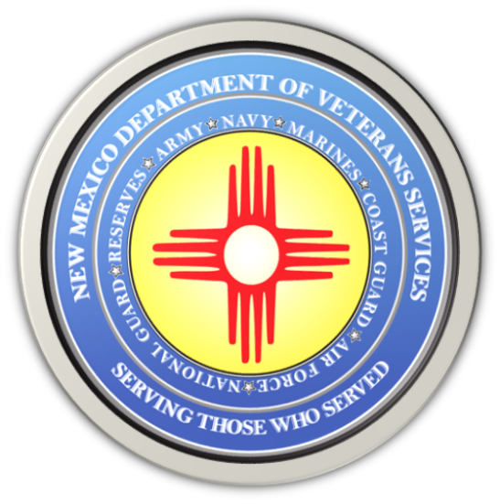

Michelle Lujan Grisham
Governor

Donnie Quintana
Cabinet Secretary

Gov. Michelle Lujan Grisham signed an executive order today-- creating the governor’s Veterans Advisory Council.

The 11-member council is attached to DVS and will support the needs of veterans in New Mexico.

The board consists of: Sr. Master Sgt. Tina Archuleta (New Mexico Air National Guard/1990-2017), Chad Autry (civilian/son of a retired Army Vietnam War veteran), Col. Reginald Clark (USAF/NMARNG/1980-2022),
Cmd. Sgt. Maj. Willy Griego (NM Army National Guard/1986-2019), Sgt. Jason Gonzales (NM Army National Guard/200-2005), Sgt. David LaCour (U.S. Army veteran), LCpl. Fred Lujan (United States Marine Corps/1961-1965), Cpl. Gilbert Platero (U.S. Army veteran), Sr. CP Chris Sedillo (U.S. Navy/1981-2007), Shirley Tetreault (Gold Star Mothers of New Mexico), and CPO3 Sam Trujillo (U.S. Navy (1963-1967).
DVS Cabinet Secretary Donnie Quintana will meet regularly with the board, which will review existing state veterans’ policies, and consult with the New Mexico veterans’ community to make sure that every veteran and their family receives the resources they have earned through their service for our state and country.

###

