The New Mexico Department of Veterans’ Services
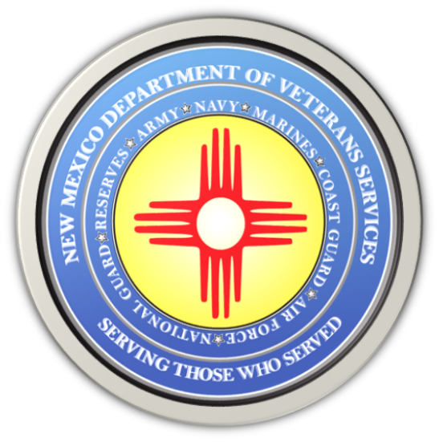

Michelle Lujan Grisham
Governor

Donnie Quintana
Cabinet Secretary

NEWS RELEASE
Contact: Ray Seva
DVS Public Information Officer
ray.seva@dvs.nm.gov
(505) 362-6089

June 14, 2023

Group of Albuquerque Seniors Take Special Rail Runner Trip to the Santa Fe National Cemetery

(Santa Fe) –New Mexico Department of Veterans’ Services (DVS) Cabinet Secretary Donnie Quintana (below/top photo) and Santa Fe National Cemetery Assistant Director Denise Baker greeted a group of 28 senior citizens from Albuquerque making a special trip to the cemetery.
Rail Runner officials organized the trip for these residents from eight assisted living facilities. The seniors took the Rail Runner Commuter Train to the Santa Fe Depot, where special Santa Fe Trails shuttle buses were waiting to bring the group to the cemetery.

The trip provides these residents—most of whom do not have transportation options—the opportunity to visit the gravesites of their veteran spouses or family members..

“I am thrilled to be able to welcome you to Santa Fe, and to this beautiful special place,” said Secretary Quintana upon the group’s arrival. “It’s important to us that families are able to visit the gravesites of their loved ones.

Secretary Quintana thanked them and their departed family members for their service and sacrifice for our country. He said DVS, the Rail Runner, Santa Fe Trails, and the cemetery are going to work together to explore making this an ongoing, regular program.

The New Mexico Department of Veterans’ Services
The New Mexico Department of Veterans’ Services (DVS) provides support and services to New Mexico’s 144,134 veterans and their families. DVS treats every veteran, regardless of their rank achieved during military service, with the respect and gratitude befitting someone who has served our country. We strive every day to live up to our agency’s official motto: Serving Those Who Served.





