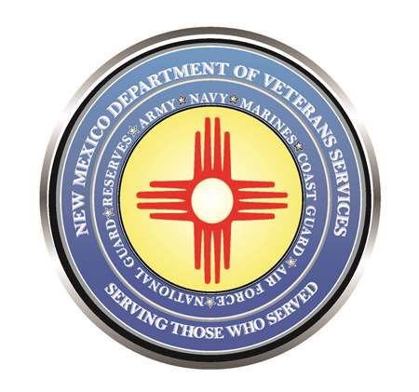

Michelle Lujan Grisham
Governor

Donnie Quintana
Cabinet Secretary

World War II WAVE Celebrates Her 100th Birthday

Former U.S. Navy WAVE Dorothy Blanchard celebrated her 100th birthday in a special closed-circuit “party” on April 29 in Albuquerque.
DVS Cabinet Secretary Donnie Quintana joined a handful of Blanchard’s family and friends at the North Domingo Baca Multi-Generation Center to
relay birthday wishes via a Zoom hookup to Jensen’s room at a nearby assisted living facility.

In 1943, then-Dorothy Jensen enlisted in the U.S. Navy’s Women Accepted for Volunteer Emergency Services program a year after it was formed. The “WAVES” were a newly-created U.S. navy Auxilliary unit of women who filled critical naval support functions here at home—allowing male service members to go off to battle in Europe and the South Pacific.

Her main function was to serve as the private secretary for Admiral Arleigh Burke at the Pentagon—including working on several classified operations at the rank of chief petty officer, and where she met and married fellow
navy Chief Petty Officer Earl Blanchard. She then worked for Assistant
Secretary of the Navy John Floberg, who was one of the key figures that helped develop our nation’s nuclear program. Her husband continued his naval service when Dorothy retired in 1952 after the birth of their daughter
Linda—who was at the birthday ceremony at the Domingo Baca facility.

“As a retired Army National Guard colonel, I am deeply appreciative of what you have done for our country,” said DVS Secretary Quintana via the Zoom connection (upper right photo). “On behalf of grateful Americans, I thank you for your military service and sacrifice—and wish you a very happy 100th birthday!”




