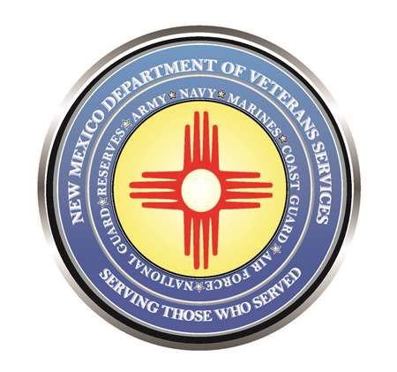

Michelle Lujan Grisham
Governor

Donnie Quintana
Cabinet Secretary

DVS Hosts Latest Local Veterans Community Briefing
on May 17 in Raton

The New Mexico Department of Veterans’ Services (DVS) hosted its latest Local Veterans Community Briefing on May 17 at the Colfax County Administrative Building in Raton.

DVS division directors presented information about the agency’s latest news—including updates on its Highly Rural Veterans Transportation Program, and the half-scale Vietnam Veterans Memorial Wall at its Vietnam Veterans Memorial in Angel Fire.

Representatives from the New Mexico VA Medical System and the Albuquerque VA Regional Office talked about the PACT Act—the new law that expands VA health care to veterans who were previously denied coverage for health issues possibly linked to exposures to toxics during their military service. Vietnam War veterans can also now apply for possible Agent Orange-related health issues.
There is also a presentation about VA home loans, and the New Mexico Department of Workforce Solutions office in Raton that helps employment-seeking residents in the region.
Click here for a video of the presentation.

###

