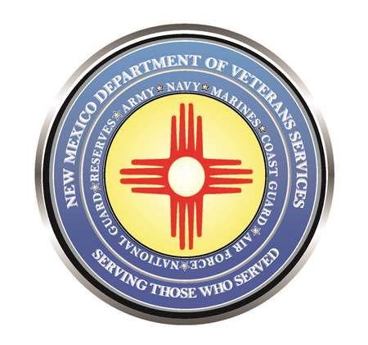

Michelle Lujan Grisham
Governor

Donnie Quintana
Cabinet Secretary

WWII Veteran Celebrates 100th Birthday in Albuquerque

DVS Cabinet Secretary Donnie Quintana helped celebrate the 100th birthday of another World War II & Korean War era—Robert Nolen--on May 18.
Secretary Quintana made a special trip to Mr. Nolen’s Albuquerque home to present a New Mexico flag, a DVS Veteran’s commemorative coin, and a birthday letter from him.
Mr. Nolen was infantryman in the Army’s 102nd Infantry Division who saw extensive combat action in Belgium. He dropped out of Texas A&M University in 1942 to immediately enlist, saying he felt compelled to serve and defend our country.

“I also have a tremendous amount of admiration and gratitude for your service for our country not once…but twice!”, said Secretary Quintana as he read aloud a birthday letter from him to Mr. Nolen. “ First, as a boots-on-the-ground U.S. Army forward scout and sniper in the Battle of the Bulge—moving ahead of the main force to scout the enemy up ahead; and then using your expertise from the great war to serve as a combat trainer during the Korean War. The lessons your learned in World War II no doubt helped our next generation of soldiers fighting against Communist forces on the Korean peninsula.”

“It takes a special kind of soldier to serve our country in two wars. As a retired New Mexico Army National Guard colonel, I am deeply appreciative of your double-service for our country. On behalf of grateful Americans, I thank you for your military service and sacrifice—and wish you a very happy 100th birthday!”





