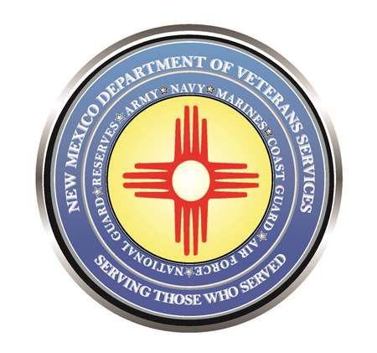

Michelle Lujan Grisham
Governor

Donnie Quintana
Cabinet Secretary

Remember The Real Meaning of Memorial Day

Monday, May 29, is Memorial Day—the day designated by Congress in 1967 to honor fallen active-duty military service members.

Americans should hold in high regard all who sacrificed to serve and protect us and our allies abroad. Much of the free world owes America’s military service members, past and present, a tremendous debt of gratitude for the safety and freedoms enjoyed by countries around the globe. However, there should be a special place in our hearts for those who’ve made the ultimate sacrifice: the men and women who’ve lost their lives while serving and protecting us.

It is for these heroes that Memorial Day is set aside. The word “hero” tends to get tossed around far too often and out of context. But it is an appropriate description of the men and women who selflessly gave of themselves carrying out their sworn duty to serve and protect Americans here at home, and our friends worldwide.

Memorial day is clearly marked on our calendar as a reminder that we are meant to stop our daily routines to remember the men and women who paid with their lives on the battlefield so we can live in a free country.

While so many of us gather with friends and family to relax, transition to warmer weather, and shop, I encourage everyone to start Monday morning with that remembrance and purpose in mind. Don't gather as groups without asking 'what does this day mean for me? For us as a country? How can I remember our fallen active-duty military service members?'

I'm issuing an open invitation to all New Mexicans to find a Memorial Day service this weekend, or on Memorial Day itself on Monday, and stand in a moment of pause to remember the ultimate sacrifices made by the men and women who died fighting for our freedoms.

If you are unable, perhaps you can take just a moment, even silently, to say a quiet “Thank You for your ultimate sacrifice.” We shouldn’t let Memorial Day pass without thanking our fallen service members.

To do so would mean their loss was in vain.

Col. Donnie Quintana, New Mexico Army National Guard (retired)
Cabinet Secretary,
New Mexico Department of Veterans’ Services
(DVS. Cabinet Secretary Donnie Quintana served 35-years with the New Mexico National Guard in several executive leadership positions--including as a brigade commander, and the adjutant general’s chief of staff. Colonel Quintana was also activated and deployed for a year to Afghanistan, where he served as executive officer and corps commander/senior mentor to the Afghan National Army as part of Operation Enduring Freedom.)

###

