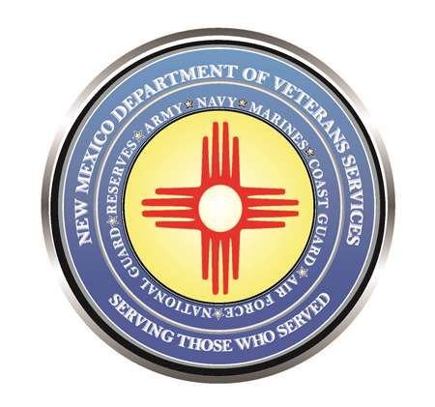

Michelle Lujan Grisham
Governor

Donnie Quintana
Cabinet Secretary

List of Memorial Day Ceremonies/Events

Below is a list of Memorial Day ceremonies/events that are known to the NM Dept. of Veterans Services…in case you decide to run a listing of statewide events or put it on your website.
DVS Cabinet Secretary Donnie Quintana will be at the Sunday ceremony in Questa…and the Monday Memorial Day ceremony at our Vietnam Veterans Memorial in Angel Fire.

There may be some ceremonies that aren’t on this list. But it was compiled based on responses from inquiries sent statewide over the past month asking for Memorial Day information.
Please click on the pdf icon below to open the list of Memorial Day ceremonies/events.

