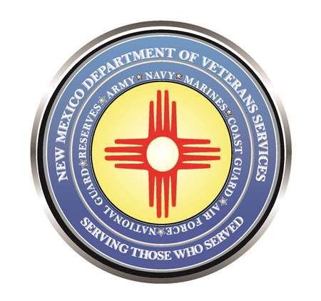

Michelle Lujan Grisham
Governor

Donnie Quintana
Cabinet Secretary

WWII Veteran Celebrates 100th Birthday in Cuyamungue

DVS Cabinet Secretary Donnie Quintana helped celebrate the 100th birthday of World War II Veteran Edward Duran on May 13.

More than 50 family members and friends attended a birthday lunch at Mr. Duran’s home in Cuyamungue, about 15-minutes north of Santa Fe.
Secretary Quintana presented Mr. Duran, who was an Army sniper who saw action in the Battle of the Bulge in Belgium, with a New Mexico flag, a DVS Veteran’s commemorative coin, and a birthday letter from him—which the secretary read aloud.

“I would like to extend my sincerest birthday wishes to you as you gather with loved ones to celebrate your 100th birthday. It takes an incredible amount of strength of body, mind, and spirit to reach the century mark. I have a tremendous amount of admiration for you for achieving this incredible milestone in life.

“I also have a tremendous amount of admiration and gratitude for your service for our country not once…but twice! First, as a boots-on-the-ground U.S. Army forward scout and sniper in the Battle of the Bulge—moving ahead of the main force to scout the enemy up ahead; and then using your expertise from the great war to serve as a combat trainer during the Korean War. The lessons your learned in World War II no doubt helped our next generation of soldiers fighting against Communist forces on the Korean peninsula.”

“It takes a special kind of soldier to serve our country in two wars. As a retired New Mexico Army National Guard colonel, I am deeply appreciative of your double-service for our country. On behalf of grateful Americans, I thank you for your military service and sacrifice—and wish you a very happy 100th birthday!”

