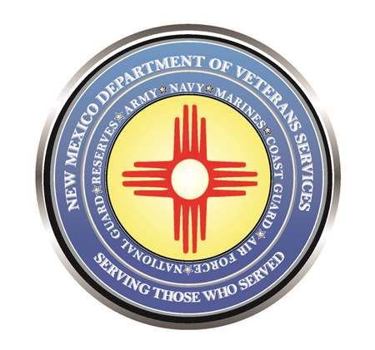

Michelle Lujan Grisham
Governor

Donnie Quintana
Cabinet Secretary

DVS and Other Agencies Presenting
the Chaves County Veterans Symposium
March 30 (8 a.m. – 5 p.m.)

Roswell National Guard Armory (1 West Earl Cummings Loop)

(Roswell) – The New Mexico Department of Veterans Services (DVS) is partnering with several federal, state, and local agencies to present the Chaves County Veterans Symposium on March 30 from 8 a.m. – 5 p.m. at the Roswell National Guard Armory, located at 1 West Earl Cummings Loop.

Veterans are strongly encouraged to stop by to learn about VA, state, and local benefits and programs for themselves and their families. DVS, VA, and other agency representatives can answer questions and even help file for health care, PTSD/mental health counseling, homelessness/housing assistance, VA home loans, employment, starting or expanding a small business, the GI Bill® college education or vocational benefit, help for women veterans, and many more programs available for veterans and their families.

PACT Act Town Hall Meeting
As an added feature, DVS Cabinet Secretary Donnie Quintana is scheduled to take part in a Pact Act Town Hall Meeting presented during the symposium by the New Mexico VA Health Care System from 10 a.m. – noon.
Veterans are encouraged to attend the meeting to learn more about the Promise to Address Comprehensive Toxics (PACT) Act—a law passed by Congress last summer that significantly expands VA health care access for veterans who believe they have health problems related to exposure to toxic substances during their military service.

The town hall meeting is an excellent opportunity to ask questions and obtains answers from New Mexico VA and DVS staff.

Veterans Property Tax Exemption/Waiver Clinic
DVS state benefits staff will also be at the symposium to assist veterans or unmarried widows of veterans with filing for the veterans property tax exemption, which is a $4,000 reduction off the taxable value of a veteran’s primary residence.

Veterans rated by the U.S. Department of Veterans Affairs (VA) as 100% service-connected, permanent-and-total disabled can file to waive the entire property tax bill.

Unmarried widows of veterans can also file for the exemption or waiver.

For more information, please contact DVS Veterans Service Officer Danielle Thompson at (575) 416-2284 or Danielle.thompson@dvs.nm.gov.

###

