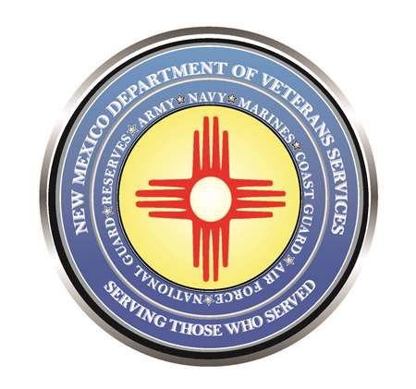

Michelle Lujan Grisham
Governor

Donnie Quintana
Cabinet Secretary

Today is National Vietnam War Veterans Day

March 29, 2023

Today is National Vietnam War Veterans Day—the date set aside by Congress for our nation to honor our men and women who served in the United States military during the Vietnam War.

It was on this date 50-years ago—March 29, 1973, that the last American military service member was pulled out of South Vietnam, and the last American prisoners-of-war were released.

More than nine million Americans served in our military during that war. Of this total, 2.7 million served in Southeast Asia. 58,220 American service members were killed in action—including 397 from New Mexico. More than 300,000 American service members were injured.

Of our six million American Vietnam War-era veterans still alive today--about 600,000 served in southeast Asia. Here in New Mexico, there are 51,370 Vietnam veterans. There are 1,500 Americans are still listed as missing in action—including 12 from New Mexico.

The Vietnam War stirred a lot of emotions here at home. According to the U.S. Department of Defense (DoD), the Vietnam War occurred from November 1, 1955, to April 30, 1975. America initially served as military advisors to South Vietnam to aid that country’s defense against threats and eventual invasion by communist-backed North Vietnam. As our country’s military involvement escalated, the war evolved into one that sharply divided our country, as more and more American service members were killed or injured.
Those who served answered the call of duty when our nation’s leaders—both Democrat and Republican—continued to call for military action to preserve freedom and democracy in Southeast Asia. Our service members responded by serving with bravery, and a sense of duty to each other. There was no time to reflect on why they were there, or what the reaction was like back home. There was an enemy to confront—one that was intent on harming them. There was no choice but to fight back—or lose your life.

Upon coming home, many returning service members were, at best, “welcomed” with indifference. At worst, many faced hostility and ridicule from an angry public. But time has allowed our nation to reflect and realize those who enlisted or were drafted into service were doing their job as members of the United States Armed Forces. Like all who wore the uniforms in the past, they deserved thanks for serving our country.

Please join me in thanking our Vietnam War veterans for their brave, courageous and honorable service for our great country, state, and their respective families. I have also attached a proclamation below from Governor Michelle Lujan Grisham honoring our Vietnam War veterans.

To our nation’s Vietnam War veterans--Welcome Home.

