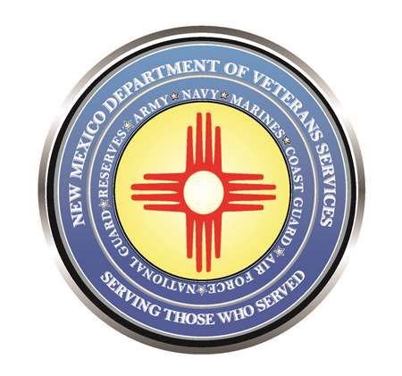

Michelle Lujan Grisham
Governor

Donnie Quintana
Cabinet Secretary

VARO, NMVAHCS, & DVS to Present
PACT Act Town Hall Meeting March 23 & 24
Mar. 23-Zuni Pueblo (1 p.m.)
Mar. 24-Crownpoint (9:15 a.m.)

(Zuni Pueblo, Crownpoint) – The Albuquerque VA Regional Office (VARO), New Mexico VA Health Care System (NMVAHCS), and the New Mexico Department of Veterans Services (DVS) are presenting PACT Act town hall meetings on March 23 in Zuni Pueblo, and March 24 in Crownpoint.

The March 23rd town hall meeting begins at 1 p.m. at the Zuni Pueblo Wellness Center, located at 31 Pincion Street.

The March 24th town hall meeting begins at 9:15 a.m. at the Navajo Technical University Wellness Center, located at State Highway 371 & Lowerpoint Road.

At both meetings, VARO Director Cesar Romero, NMVAHCS Director Robert McKenrick, and DVS Cabinet Secretary Donnie Quintana are scheduled to present information and answer questions about the Honoring our Promise to Address Comprehensive Toxics (PACT) Act, which was recently signed into federal law to expand VA health care and benefits for veterans who believe they may be suffering from health problems due to service-related exposures to toxic substances.

Many Iraq and Afghanistan War veterans have been denied VA health care for post-service health issues they’ve long claimed were caused by exposure to toxic chemicals from “burn pits” during their service in the Middle East. Many Vietnam War veterans have developed health issues they’ve long claimed are linked to their exposure to the Agent Orange defoliant used in southeast Asia during the Vietnam War.
The PACT Act may also benefit veterans exposed to toxics in other service areas. Veterans who suspect they may have developed health issues due to their service are encouraged to attend the meeting.
A similar town hall meeting is scheduled for March 30 at the Roswell National Guard Armory.

The New Mexico Department of Veterans Services
The New Mexico Department of Veterans Services (DVS) provides support and services to New Mexico’s 144,134 veterans and their families. DVS treats every veteran, regardless of their rank achieved during military service, with the respect and gratitude befitting someone who has served our country. We strive every day to live up to our agency’s official motto: Serving Those Who
Served.

###

