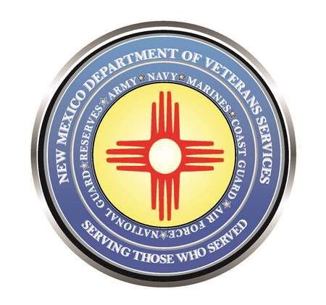

Michelle Lujan Grisham
Governor

Donnie Quintana
Cabinet Secretary-Designate

DVS to Host Veterans Property Tax Exemption/Waiver Clinics

(Santa Fe) – The New Mexico Department of Veterans Services (DVS) will hold veterans property tax waiver and exemption clinics in the following communities:

Bernalillo - Mar. 10 (11am-3pm) | Pojoaque - Apr. 17 (10am-2pm)
Sandoval County Assessor’s Office | Pojoaque Satellite Office
1500 Idalia Rd./Bldg. D | 17839 U.S. Hwy 84/285
Clovis - Mar. 22 (9am-3pm) | Farmington - Apr. 18 (10am-2pm)
American Legion Post 25 | San Juan County Assessor’s Office
2400 West 7th. St. | 100 South Oliver Dr. #400
Roswell - Mar. 30 (8am-5pm) | Las Cruces - Apr. 20 (10am-2pm)
National Guard Armory | Doña Ana County Assessor’s Office
1 West Earl Cummings Loop | 845 North Motel Blvd.
*part of the Chaves County Veterans Symposium
 | **Los Lunas - May 5 (10am-2pm)
Edgewood - Apr. 10 (10am-2pm) | Daniel Fernandez Recreation Center
Edgewood Senior Center | 1103 NM Hwy 314
114 Quail Trail | **part of the Valencia County Senior Expo & Health Fair
Santa Fe - Apr. 13 (10am-2pm) | Gallup - May 12 (10am-2pm)
Santa Fe County Fairgrounds | McKinley County Assessor’s Office
3229 Rodeo Rd. | 207 West Hill Ave.

Veterans and unmarried widows of veterans can file for the veterans property tax exemption, which is a $4,000 reduction off the taxable value of a veteran’s primary residence. Veterans rated by the U.S. Department of Veterans Affairs (VA) as 100% permanent service-connected-disabled can file to waive all property tax on their primary residence.

Unmarried widows of veterans can also file for the exemption or waiver.

Proof of veteran status and New Mexico residency required
To expedite the filing process, veterans and surviving spouses of veterans must bring a copy of one of the following forms to show veteran status:
- DD-214
- National Oceanic Atmospheric Administration (NOAA) form 56-16
- Public Health Service (PHS) for 1867
If filing for a disabled veteran tax waiver:
- VA award letter declaring 100% permanent and total service-connected disability

For proof of New Mexico residency, please bring one of the following:
- Current NM driver’s license
- Voter registration card
- Latest NM income tax return

For more information, please contact DVS Event Coordinator Joseph Dorn at joseph.Dorn@dvs.nm.gov or (505) 861-9117.

###

