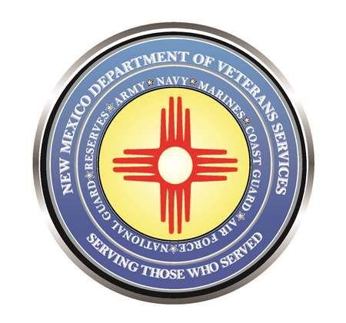

Michelle Lujan Grisham
Governor

Donnie Quintana
Cabinet Secretary-Designate

Retired NM National Guard Col. Donnie Quintana Unanimously Confirmed as DVS Cabinet Secretary

(Santa Fe) – Retired New Mexico National Guard Colonel Donnie J. Quintana was unanimously confirmed by the New Mexico Senate as the new cabinet secretary of the New Mexico Department of Veterans Services.

He had been serving on an interim basis since Governor Michelle Lujan Grisham named him to fill the vacant DVS cabinet secretary position last November.

Secretary Quintana has already served more than 20 years in state government. Most recently, he was a local government division director at the New Mexico Department of Finance, where he oversaw coordination of state, federal, and local programs helping with the development and growth of communities throughout the state.
The Pecos native previously served 35-years in several executive leadership positions with the National Guard, including as a brigade commander, and the adjutant general’s chief of staff. He was also activated and deployed for a year to Afghanistan, where he served as executive officer and corps commander/senior mentor to the Afghan National Army as part of Operation Enduring Freedom.

At this morning’s senate confirmation hearing, several Democrat and Republican senators spoke highly of Secretary Quintana—many of whom have worked with him during his state government service.

“You want to talk about a true, honest person. his heart is in the right place,” said Sen. George Muñoz (D-Cibola, McKinley, & San Juan Counties) “Always hard working, always polite, always good to be around—he’s known as someone you can count on—and that’s a good thing for New Mexico’s veterans and their families.”

“I think what Colonel Quintana brings to this position is an extensive background—he’s worked in state government, and in the National Guard,” said Sen. Jerry Ortiz y Pino (D-Bernalillo). “He’s worked in the local government division, where he was described by that secretary—his former boss at the Department of Finance--as the person she always turned to if something had to get done fast, and get it done right.”

State Senator Pat Woods (R-Curry, Quay, & Union) said he was impressed with how quickly Secretary Quintana stepped in at the last minute to help with the funeral of the senator’s father.

“I just want to brag for this gentleman, Colonel Quintana. He just recently helped me get an Honor Guard for my dad. I was very much appreciative of that,” said Senator Woods. “When I was in the House, Rep. Bob Wooley was my office mate. We just talked this morning, and he wanted me to stand strongly in support and vote ‘yes’ on Colonel Quintana.”

After the confirmation, Secretary Quintana reflected on the hearing, saying he was truly humbled by the process, which included similar strong words of support in earlier confirmation committee hearings.

“I was overwhelmed hearing the kind words from the legislators—from both sides of the aisle,” said Secretary Quintana. “I want to thank them for their support—it means so much to me. I look forward to forging new working relationships with others. I’ll need their support to help me and the rest of DVS fulfill our mission of providing the best service to New Mexico’s veterans and their families.”

###

