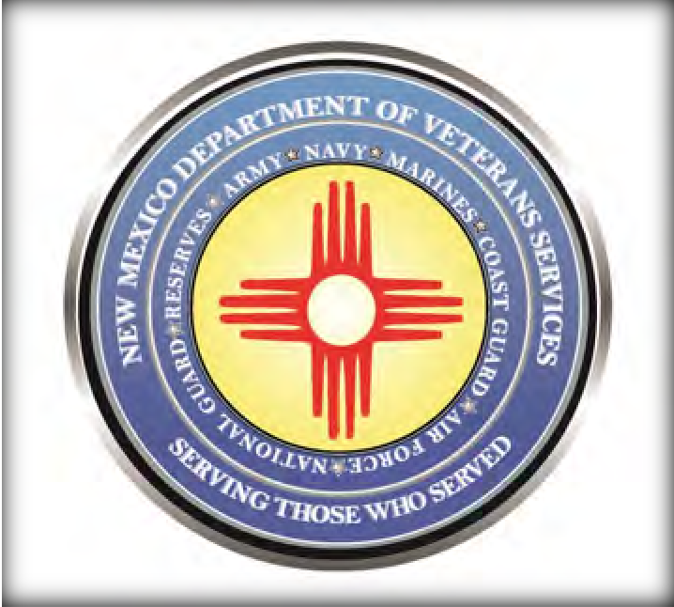
DVS Field Offices in New Mexico
DVS has field offices throughout the state that are staffed with nationally accredited veterans service officers who are dedicated to helping veterans with filing VA claims, applying for state veterans benefits, or with helping with anything else a veteran or their family needs with.

Office hours are Monday-Friday from 8am-5pm, (excluding holidays).
Though this service is free, appointments are required and can be made by contacting the VSOs below. Please note: in addition to in-office assistance, veterans from anywhere in the state can also contact any DVS VSO for assistance by phone or email.

Alamogordo/Southeast NM | Albuquerque Metro Area | Albuquerque Metro Area
David Henley | Dayle Bad Warrior | Austin Walker
411 10th Street #107 | 5201 Eagle Rock Blvd. NE/Suite 2 | 5201 Eagle Rock Blvd. NE/Suite 2
(575) 937-5620 | (505) 383-2400 | (505) 274-0393
david.henley@dvs.nm.gov | dayle.badwarrior@dvs.nm.gov | austin.walker@dvs.nm.gov
Albuquerque Metro Area | Belen/Albuquerque Metro Area | Carlsbad/Southeast NM
Hope Najera | (opening soon) | Dagmar Youngberg
5201 Eagle Rock Blvd. NE/Suite 2 | 718 South Main St/Space A, Unit 8 | 101 N. Halagueno
(505) 383-2400 | (TBD) | (575) 988-5900
hope.najera@dvs.nm.gov | TBD | dagmar.youngberg@dvs.nm.gov
Clovis/Southeast NM | Clovis/Southeast NM | Farmington/Northwest NM
Matt Barela (region supervisor) | Ben Padilla | Robert Guinn (region supervisor)
904 W. Sixth St. (575)  825-9602 | 904 W. Sixth St.  (505) 537-1445 | San Juan College Vet Center/  Room 1715-B
matthew.barela@dvs.nm.gov | ben.padilla@dvs.nm.gov | (505) 327-2861
 |  | robert.guinn@dvs.nm.gov
Farmington/Northwest NM | Gallup/Northwest NM | Grants/Northwest NM
Temporarily vacant. Please | John Livingston | April Ball
contact the other Farmington VSO for in-office assistance...or any DVS VSO for phone or | 908 E. Buena Vista Ave/Room 1A  (505) 389-8731  john.livingston@dvs.nm.gov | 908 E. Buena Vista Ave/Room 1A  (505) 389-8731  april.ball@dvs.nm.gov
email benefits assistance
 | (more offices are on the next page)

Hobbs/Southeast NM | Las Cruces/Southwest NM | Las Cruces/Southwest NM
Fred Solis-Littlejohn | Miguel Martinez (supervisor) | Vincent Tellez
2120 North Alto St. | 2024 E. Griggs Ave. | 2024 E. Griggs Ave.
(575) 241-0714 | (505) 216-8782 | (505) 216-8782
fred.solis-little@dvs.nm.gov | miguel.martinez@dvs.nm.gov | vincent.tellez@dvs.nm.gov
Las Cruces/Southwest NM | Las Vegas, NM/Northeast NM | Las Vegas/Northeast NM
Clint Anderson | Martín Márquez (supervisor) | Arturo Marlow
2024 E. Griggs Ave. | 917 Douglas Ave. | 917 Douglas Ave.
(505) 216-8782 | (575) 520-5079 | (505) 331-8838
clint.anderson@dvs.nm.gov | Martin.marquez@dvs.nm.gov | arturo.marlow@dvs.nm.gov
Rio Rancho/Albuquerque Metro | Roswell/Southeast NM | Santa Fe/Northwest NM
Dustin Newsom | Danielle Thompson | Nick McKenzie
Sandoval County Admin. Bldg.  1500 Idalia Rd./Bldg. D, Room 2041 | 1600 SE Main Street /Suite 2A  (575) 416-2284 | Bataan Memorial Bldg. 1st  Floor/Room 134/407 Galisteo St
(505) 221-7190 | danielle.thompson@dvs.nm.gov | (505) 218-3125
dustin.newsom@dvs.nm.gov |  | nicholas.mckenzie@dvs.nm.gov
Silver City/Southwest NM | Taos/Northwest NM
Clarissa Sierra | Leticia “Lety” Cano
Western New Mexico University | Health & Human Services Bldg/
Juan Chacon Bldg/Rm. 138A | 145 Roy Rd.
1000 West College Ave. | (575) 709-5263
(505) 313-5627 | leticia.cano@dvs.nm.gov
clarissa.sierra@dvs.nm.gov
Women Veterans Program/VSO | Pueblos & Tribal Liaison
Theresa Figueroa | Beverly Charley
DVS Albuquerque Office  5201 Eagle Rock Blvd. NE/Suite 2 | San Juan College Veterans Center  4601 College Blvd./Room 1715-B
(505) 916-7449 | (575) 241-3322
theresa.figueroa@dvs.nm.gov | beverly.charley@dvs.nm.gov

