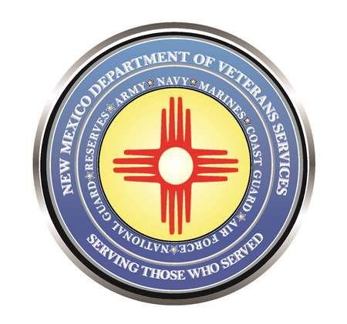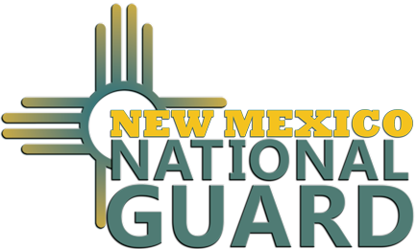

Michelle Lujan Grisham
Governor

Donnie Quintana
Acting DVS Cabinet Secretary

BG Miguel Aguilar
New Mexico Army National Guard/
Adjutant General of New Mexico

February 20 is Military & Veterans Day at the 2023 Legislature
At the State Capitol in Santa Fe

(Santa Fe) – Military Veterans, National Guard/Reserve members, and active service members will be honored at the State Capitol in Santa Fe on February 20 on Military and Veterans Day at the 2023 Legislature.

This annual day during the legislative session is presented by the New Mexico Department of Veterans Services (DVS) and the New Mexico National Guard to honor New Mexico’s military community for their sacrifice and service for our country.

The day will feature informational tables staffed by DVS, NMNG, the New Mexico VA Health Care System, VA’s Veterans Benefits Administration Albuquerque office, veterans groups, and community service organizations in the east and west wings of the Rotunda. Wrapping up the day will be a noon ceremony in the Capitol Rotunda honoring our current and former service members.

Veterans, active service members, their families, and the public are invited to stop by the Capitol to learn more about New Mexico’s military community. Military & Veterans Day at the 2023 Legislature is also a great opportunity for veterans and service members to meet with your local legislators and their staff to talk about any legislative matters of importance.

Very Limited Space Available for Informational Tables
Due to new regulations, there is an extremely limited number of informational table space available this year for interested veterans service agencies or community service organizations.
DVS is asking interested organizations to email a table request to DVS Event Coordinator Joseph Dorn at joseph.dorn@dvs.nm.gov by January 31. DVS will conduct a random drawing on February 1 to fill the remaining table spaces. Successfully drawn organizations will be notified by email. No phone reservations will be accepted.

The New Mexico Department of Veterans Services
The New Mexico Department of Veterans Services (DVS) provides support and services to New Mexico’s 151,000 veterans and their families. DVS treats every veteran, regardless of their rank achieved during military service, with the respect and gratitude befitting someone who has served our country. We strive every day to live up to our agency’s official motto: Serving Those Who Served.

###

