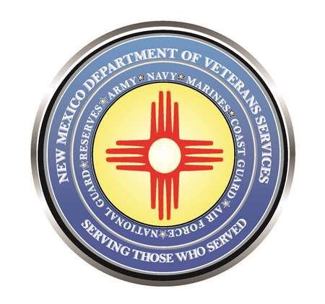

Michelle Lujan Grisham
Governor

Donnie Quintana
Acting Cabinet Secretary

DVS to Present First Local Community
Veterans Call Meeting of 2023 in Taos
January 4, 2023 (9 a.m. - noon)
Taos County Administration Complex (105 Albright St.)

(Taos)– The New Mexico Department of Veterans Services (DVS) will present its first Local Community Veterans Call meeting of 2023 in Taos on January 4 from 9 a.m. to noon in the Taos County Commissioners Chamber at the Taos County Administration Complex, located at 105 Albright Street.

DVS staff will provide updates on DVS initiatives for 2023, and an update on agency and other veteran-related legislation expected to be introduced at the 2023 New Mexico Legislature, which is a 60-day session this year that convenes on January 17 and adjourns on March 18.

Scheduled to join DVS at the briefing are representatives from the New Mexico VA Health Care System and the Albuquerque VA Regional Office, who will also provide updates on VA care and services.

DVS will videotape the briefing and will post an edited video of the proceedings on its website.

###

