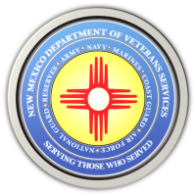
The New Mexico Department of Veterans Services

November 11 is Veterans Day
November 11 is Veterans Day, the day designated by Congress to honor the service of all men and women who have served our country as members of the United States military.

DVS Cabinet Secretary Sonya Smith will be joined by DVS division directors in commemorating the day at the 2022 Southwest Native American Veterans Health & Wellness Symposium at the Isleta Resort and Casino in Albuquerque.

There are many other Veterans Day ceremonies and events going on around the state. Below and on the next page is a list of events based on information provided to DVS by members of the veteran community. Below is a list of Veterans Day events compiled from information sent to the agency. DVS urges veterans to attend a ceremony to celebrate the day dedicated to them and their sacrifices made to serve our country.

