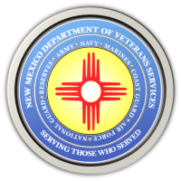
The New Mexico Department of Veterans Services

Michelle Lujan Grisham Governor
Sonya L. Smith Cabinet Secretary

DVS to Provide Assistance at 2022 San Juan County Stand Down for Homeless Veterans & Families

Friday, October 14 (8 a.m.-2:30 p.m.)
Farmington
San Juan College/Health & Human Performance Center
(4601 College Blvd.)

(Farmington)—The New Mexico Department of Veterans Services (DVS) will be among nearly three dozen state, federal, and local agencies providing assistance at the 2022 Stand Down for Homeless Veterans and Their Families on October 14 from 8 a.m. to 2:30 p.m. at the San Juan College.

The Stand Down will be inside the college’s health & human performance center, at 4601 College Blvd.

In addition to food and clothing, homeless and at-risk veterans can obtain free backpacks, bedding, hygiene kits, flu shots, basic medical screening, legal consultation, and many other goods and services. Free dental care will also be available.

Representatives from DVS will be there helping attendees file VA medical and behavioral counseling, and other VA benefits claims. Other agencies can help with employment assistance, temporary and long-term housing, and other support services available in the Four Corners area.
The stand down concept is modeled after military stand downs popularized during the Vietnam War to offer battle-weary soldiers a temporary safe haven to rest, receive medical treatment, get a hot meal, and receive other services before returning to combat action.

For more information, contact DVS Tribal & Pueblo Liaison Beverly Charley at (575) 241-3322.

