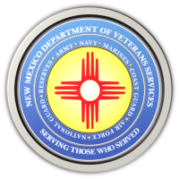

**The New Mexico Department of Veterans Services**

**Michelle Lujan Grisham** *Governor*

**Sonya L. Smith** *Cabinet Secretary*

**Video of the October 6 “PACT Act” Albuquerque Town Hall Meeting**

President Joe Biden recently signed into law the “PACT Act.” This landmark veterans health care law opens the door for eligible veterans suffering from toxic exposure-related medical issues to file VA health care claims.  
  
On October 6, the New Mexico Department of Veterans Service (DVS), the Albuquerque VA Regional Office (VARO), and the New Mexico VA Health Care System (NMVAHCS) presented a *PACT Act* town hall meeting in Albuquerque to answer questions from an in-person and online/virtual audience.

DVS Cabinet Secretary Sonya Smith, DVS Field Services Division Director Robin Wilson, NMVAHCS Director Robert McKenrick, and VARO Director Cesar Romero explained more in detail what the PACT Act means for eligible veterans, and how to go about filing a claim for VA health care.

DVS videotaped the meeting—which can be found by clicking on the link below:

[**https://www.youtube.com/watch?v=_gko4onO8Wc**](https://www.youtube.com/watch?v=_gko4onO8Wc)

###