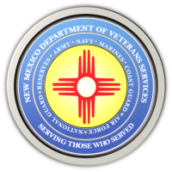
The New Mexico Department of Veterans Services

Michelle Lujan Grisham Governor
Sonya L. Smith Cabinet Secretary

Video Highlighting the 2022 Forgotten Heroes Funeral

On September 29, 29 veterans were laid to rest with military honors during the 2022 Forgotten Heroes Funeral at the Santa Fe National Cemetery.

These 26 men and 3 women, upon their deaths, were not claimed for burial by any family or friends. The Forgotten Heroes Funeral made sure they were not forgotten, and were buried as honorably discharged veterans.

The New Mexico Department of Veterans Services (DVS) has produced a short video highlighting the funeral—with more information about how it provides a “final salute” for previously-forgotten deceased veterans here in New Mexico.

https://www.youtube.com/watch?v=NiQ1oiTp3qg

###

