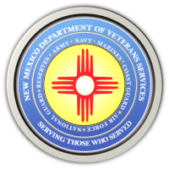
The New Mexico Department of Veterans Services
Michelle Lujan Grisham Governor
Sonya L. Smith Cabinet Secretary
2022 Northern New Mexico Honor Guard Conference

The 2022 Northern New Mexico Honor Guard Conference was held on September 15, 2022, at the New Mexico Veterans Memorial in Albuquerque.

This annual training conference is presented by the New Mexico Department of Veterans Services, the New Mexico National Guard, and AARP New Mexico for the benefit of northern New Mexico's all-volunteer honor guards. (A similar southern New Mexico conference was held in the spring)

The conferences provides training and coaching for the volunteer units by honor guards from the NM National Guard. These volunteer honor guards render military honors at the majority of veterans' funerals in New Mexico. DVS has produced the video below showing highlights of the training and coaching...along with the ensuing performing of simulated funerals by the volunteer units.





