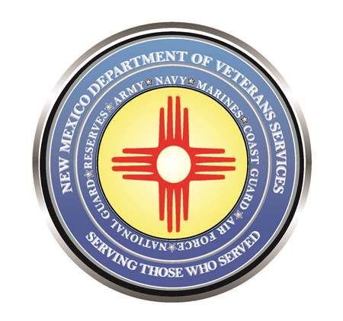

Michelle Lujan Grisham
Governor

Sonya L. Smith
Cabinet Secretary

Twenty-Nine Veterans to be Laid to Rest
at the 2022 Forgotten Heroes Funeral

Thursday, Sep. 29 (11a.m.)
Santa Fe National Cemetery
501 North Guadalupe St.

(SANTA FE)— The unclaimed cremated remains of 29 military veterans will be laid to rest at the 2022 Forgotten Heroes Funeral at 11 a.m. on Thursday, September 29, at the Santa Fe National Cemetery.

The cemetery is in the city’s north side, at 501 North Guadalupe Street.

The annual funeral, presented by the New Mexico Department of Veterans Services (DVS), Bernalillo County, and Director’s Choice Mortuary Services of Albuquerque, provides a military burial for any veteran in New Mexico who upon death is unclaimed by family. This joint effort ensures that no veteran is alone at the end, and that he or she receives a military honors funeral available to our nations honorably discharged veterans.

Of the 29 sets of cremains, three are from Doña Ana County. Two are from Otero County. The remaining 26 are from Bernalillo County. Three of the 29 are women veterans.

Prior to interment, there will be a brief 9 a.m. memorial service at the Strong Thorne Mortuary Chapel near downtown Albuquerque, at 1100 Coal Avenue SE. After the memorial, the urns containing the 29 sets of cremains will be loaded into a hearse, which will then receive a motorcycle escort by members of law enforcement and the American Legion Riders to the Santa Fe National Cemetery.

The public is invited to attend and serve as “family” to provide a final salute for these 29 fallen veterans who served our country.

###

