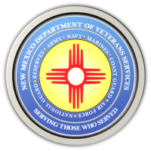
The New Mexico Department of Veterans Services

Michelle Lujan Grisham Governor
Sonya L. Smith Cabinet Secretary

DVS Produces Short Video Honoring the Department’s
Navy Veterans During Navy Week 2022

In honor of the U.S. Navy celebrating Navy Week in Albuquerque September 12-18, the New Mexico Department of Veterans Services (DVS) has produced a short (1:30) video showing the department’s seven Navy veterans.
https://www.youtube.com/watch?v=z4w3wOMDGsE
DVS would like to thank our nation’s Navy veterans for their service and sacrifice for our country.

###

