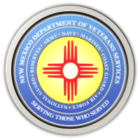
The New Mexico Department of Veterans Services

Michelle Lujan Grisham Governor
Sonya L. Smith Cabinet Secretary

New Mexico Department of Veterans Services Secretary Sonya Smith was among the estimated 300 people welcoming home the 2022 Northern New Mexico Honor Flight back to Albuquerque on June 3.

The crowd gave the group of 25 military veterans—2 from World War II, 11 from the Korean War, and 12 from the Vietnam War—a hero’s welcome from their two-day visit to the national war memorials in Washington, D.C.

Here is a link to a short video showing the scene at the Albuquerque International Sunport.
https://youtu.be/GZ--eBTkBS0

###

