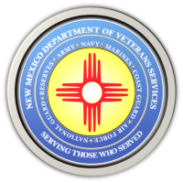

Michelle Lujan Grisham Governor
Sonya L. Smith Cabinet Secretary

DVS Presents the First-Ever
Southern New Mexico Honor Guard Training Conference

The New Mexico Department of Veterans Services (DVS), along with the New Mexioc National Guard and AARP-New Mexico, presented the first-ever Southern New Mexico Honor Guard Training Conference. The conference provides a learning opportunity for the state’s all-volunteer Honor Guards that render military honors at the majority of the state’s funerals of veterans.

Training was provided by New Mexico National Guard Honor Guards.

https://www.youtube.com/watch?v=XYcxHjMLWjQ

